

**Title: Qualitative and Quantitative Fundamental Analysis of 5 listed companies of the same sectors for the span of 10 years.**

**Guided By: Vemulapalli Aparna**

**Submitted By:**

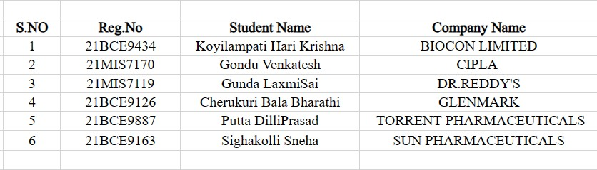

**CONTENT:**

**INTRODUCTION:**

TORRENT PHARMACEUTICAL LIMITED: It was founded in 1959. Torrent Pharmaceuticals operates in more than 40 countries with over 2000 product registrations globally. Torrent Pharma is active in the therapeutic areas of Cardiovascular (CV), central nervous system (CNS), gastro-intestinal, diabetology, anti-infective and pain management segments.

GLENMARK PHARMACEUTICAL: It was founded in 1977. These generics medicines are impact over 100 million patients each year globally. A global supplier of high quality API products and a preferred partner for pharmaceutical companies worldwide. Through Glenmark Foundation, the CSR activities are largely focused in the areas of Child Health and over the years we have impacted over 900,000 lives globally.

BIOCON LIMITED: It was founded in 1978. The company is a biopharmaceutical company, develops, manufactures, and sells biopharmaceuticals for diabetes, cancer, and autoimmune conditions. It products Small Molecules (APIs & Generic Formulations), Biosimilars, Branded Formulations, Research Service.

Dr Reddy's: It was founded in 1986.Its portfolio has over 200 products covering the whole spectrum of disease areas spanning gastroenterology, oncology, pain management, cardiovascular, dermatology, urology, nephrology, rheumatology and diabetes. Dr. Reddy’s have an unmatched global regulatory expertise focused on international markets.

CIPLA: It was founded in 1935. Cipla Quality as a centre of excellence assures a culture of compliance and follows systematic interventions to consistently meet or exceed quality standards. Reputation of delivering consistently high-quality products has helped us to be considered as one of the key partners of choice for multinational Government and Non-Government institutions globally.

SUN PHARMACEUTICALS: It was founded in 1983. Supported by more than 40 manufacturing facilities, we provide high-quality, affordable medicines, trusted by healthcare professionals and patients, to more than 100 countries across the globe. Its core strength lies in our ability to excel in developing generics and technologically complex products backed by our dedicated teams in formulations, process chemistry, and analytical development.

RATIO ANALYSIS:

Ratio analysis is anaccounting method that uses financial statements, like balance sheets and income statements, to gain insights into a company's financial health. Ratio analysis will help determine various aspects of an organization including profitability, liquidity and market value.

QUALITATIVE ANALYSIS:

Qualitative data analysis is aprocess of evaluating industrial data based on subjective data. Itis a research tool used in businesses in order to analyse an organization’s overall value based on non-quantifiable indicators.

QUANTITATIVE ANALYSIS:

Quantitative analysis is theuse of mathematical models to analyse data points, with the intent of understanding a condition. This analysis is used to predict future outcomes, and is a key concept in financial modelling and other areas.

Therefore, Qualitative analysis differs from quantitative analysis in terms of measurement. Both qualitative and [quantitative analysis](https://corporatefinanceinstitute.com/resources/knowledge/finance/quantitative-analysis/) will be used together in order to extensively examine an organization’s trajectory and potential, both of which are incredibly important indicators used to determine investment opportunities.

**RATIO ANALYSIS:**

**3.DR REDDY’S**

**LIQUIDITY RATIOS:**

**Current Ratio:**

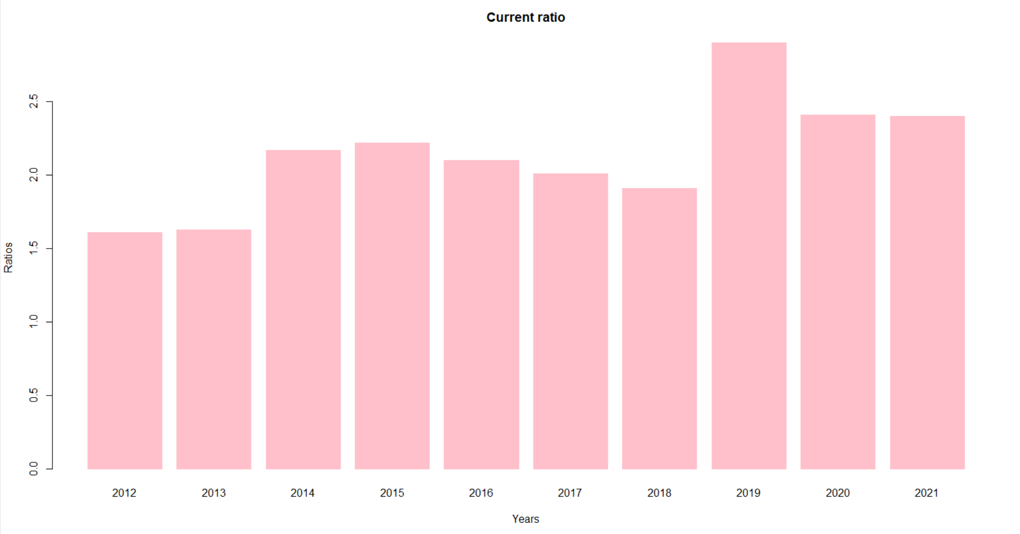

* The current ratio indicates the ability of a company to generate cash from  [current assets](https://efinancemanagement.com/working-capital-financing/current-assets-key-features) to pay [current liabilities](https://efinancemanagement.com/financial-accounting/current-liability-meaning-accounting), which become due in the short term.
* A ideal current Ratio is 2:1 ,if it is 1:1 then it is impossible to get profit.
* Except years 2012 and 2013 all having more than 2 and year 2019 has higher current ratio that says their financial position is better by getting more profit.
* The low current ratio is a direct sign of a high risk of bankruptcy, and too high would impact the profits adversely.

**Quick Ratio:**

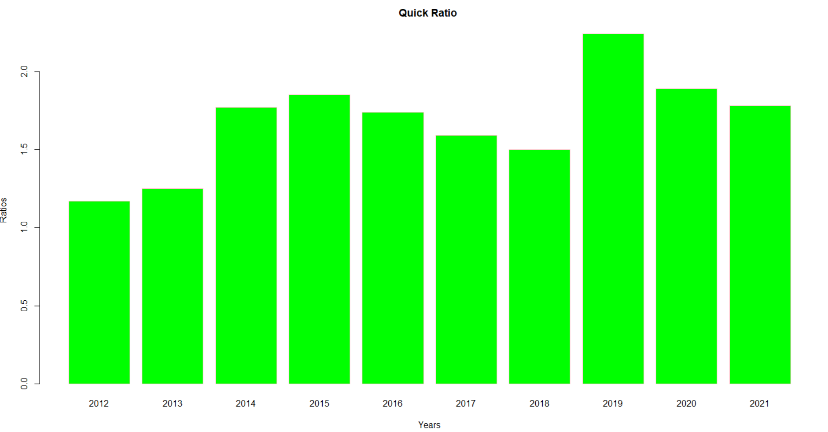

* The quick ratio measures a company's capacity to pay its current liabilities without

needing to sell its inventory or obtain additional financing.

* The ideal standard ratio is 1: 1. Here all are above 1, so these are good enough.
* 2019 has higher ratio that can say that better a company’s liquidity and financial health.
* In 2012,2013 it is low compared to remaining. The lower the ratio, the more likely

the company will struggle with paying debts.But here it is ok because it is more than 1.

**Acid test ratio:**

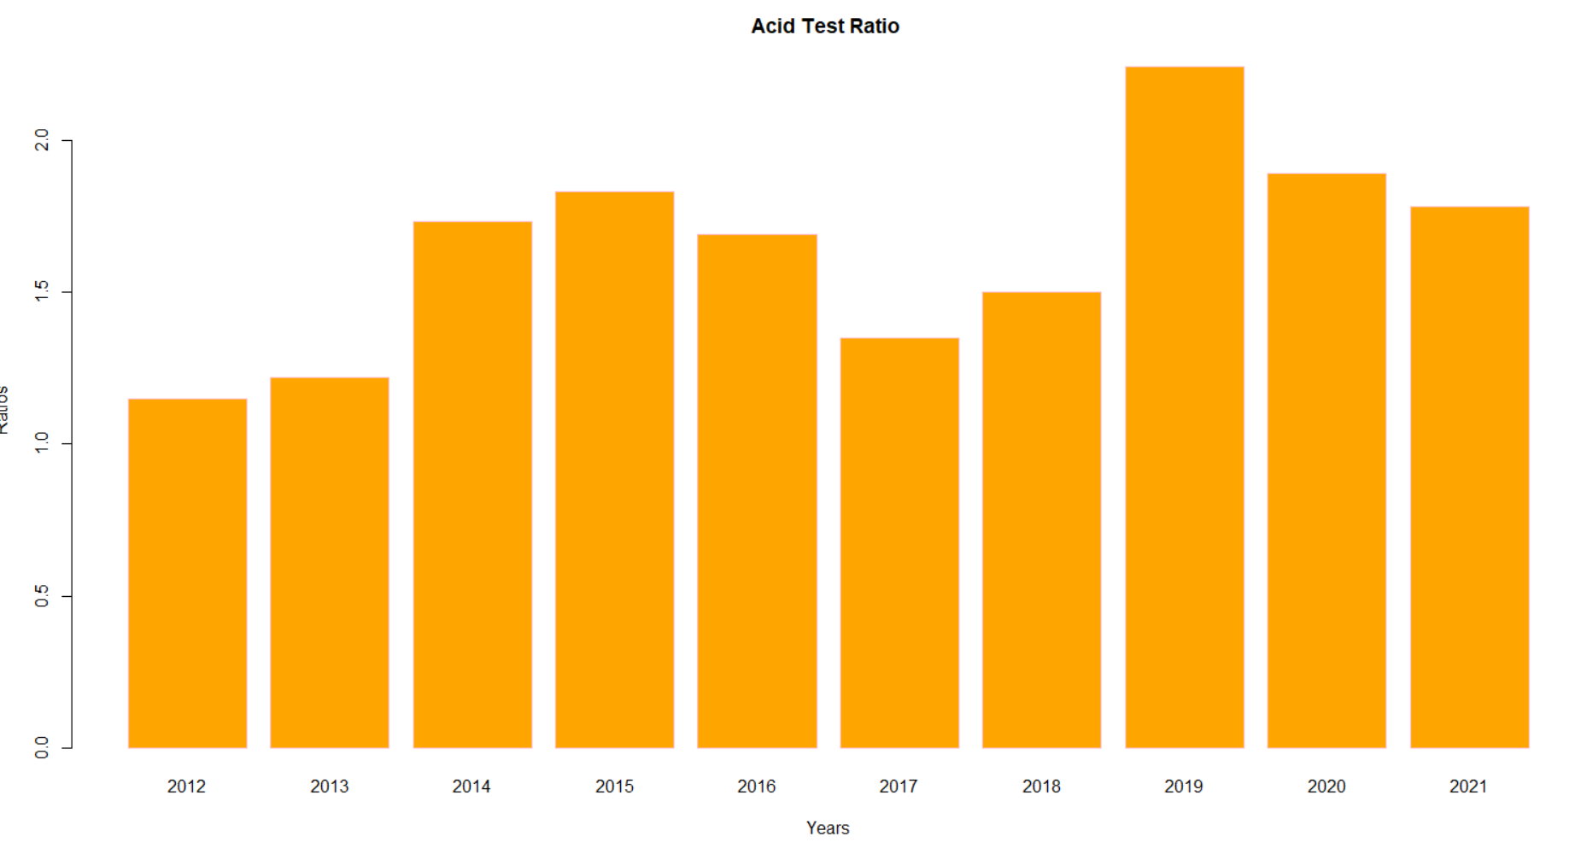

* An acid ratio test, same as a quick ratio, measures the ability of a company to use their short-term assets to cover their immediate liabilities.
* An acid test ration greater than 1 is considered healthy and is important for external stakeholders like creditors, lenders, [investors](https://www.freshbooks.com/hub/leadership/find-investors-small-business) and capitalists.
* So we can say from graph this company has good acit test ratios. If a company has a ratio of less than 1, they cannot currently fully pay back its current liabilities.
* A high or increasing acid test ratio as in year 2019 indicates a company has faster inventory turnover and cash conversion cycles than the other years.

**Inventory Turnover Ratio:**

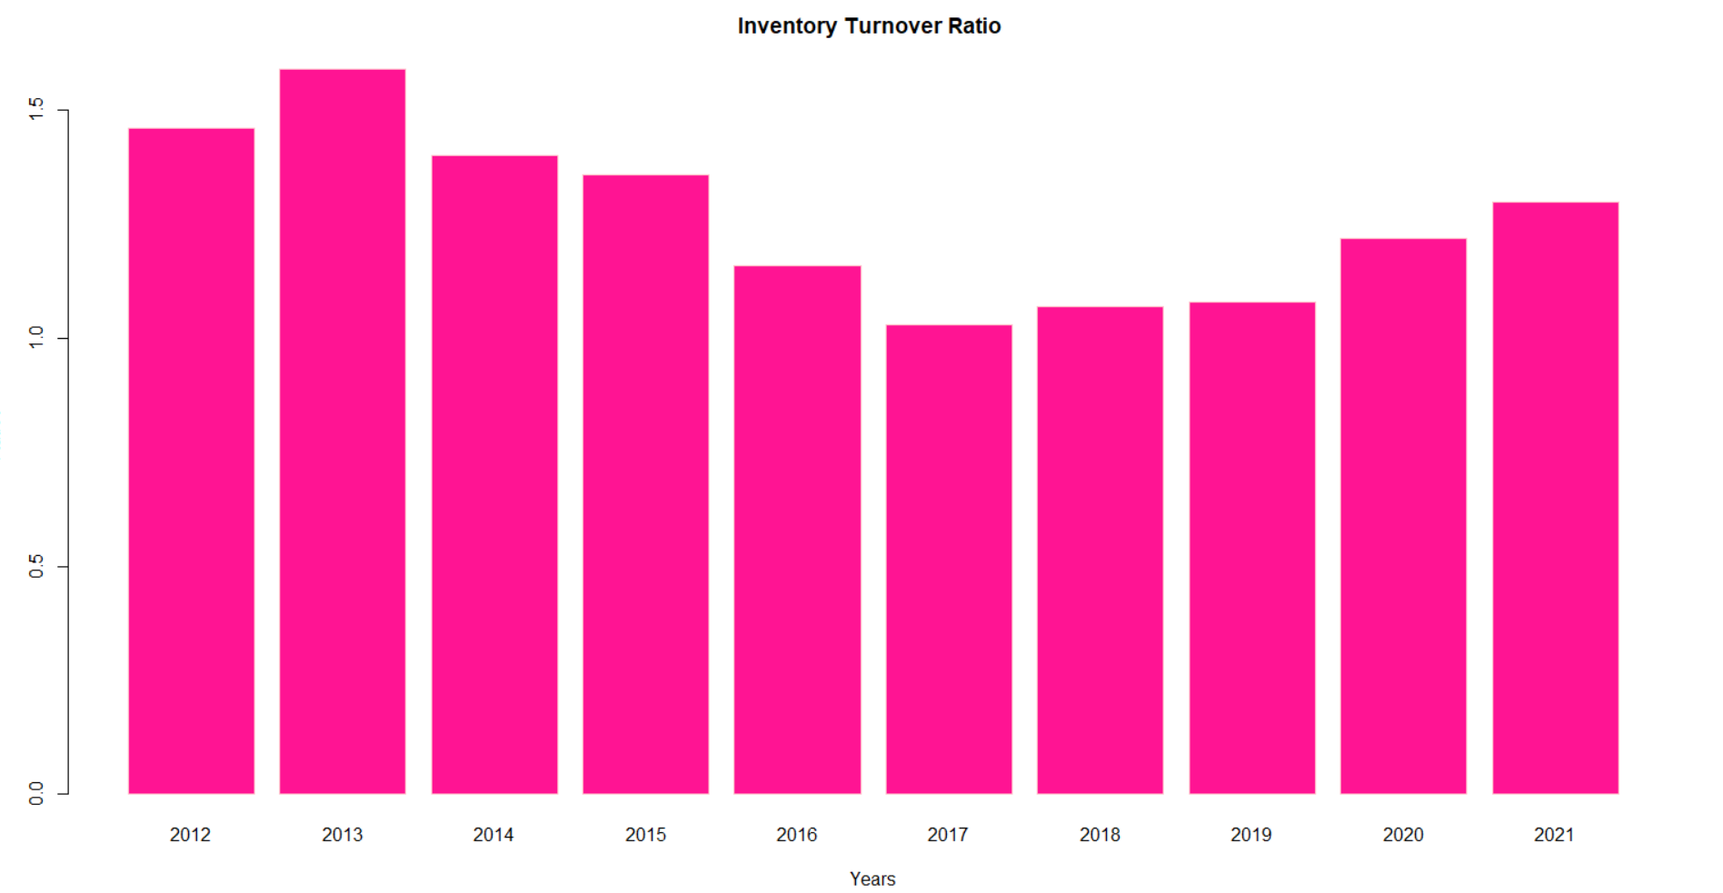

* Inventory turnover is important because it highlights how efficient a company is at converting inventory into final sales and cash.
* From year 2013 to 2017 the ratio is falling that means company holding more stock which will increases carriage costs. Profit will not come from this rate of inventory ratio.
* It is increasing from the 2017 to 2021,that means it will able to convert inventory and get profit in a little bit faster rate than remaining years.

**Inventory Collection Days:**

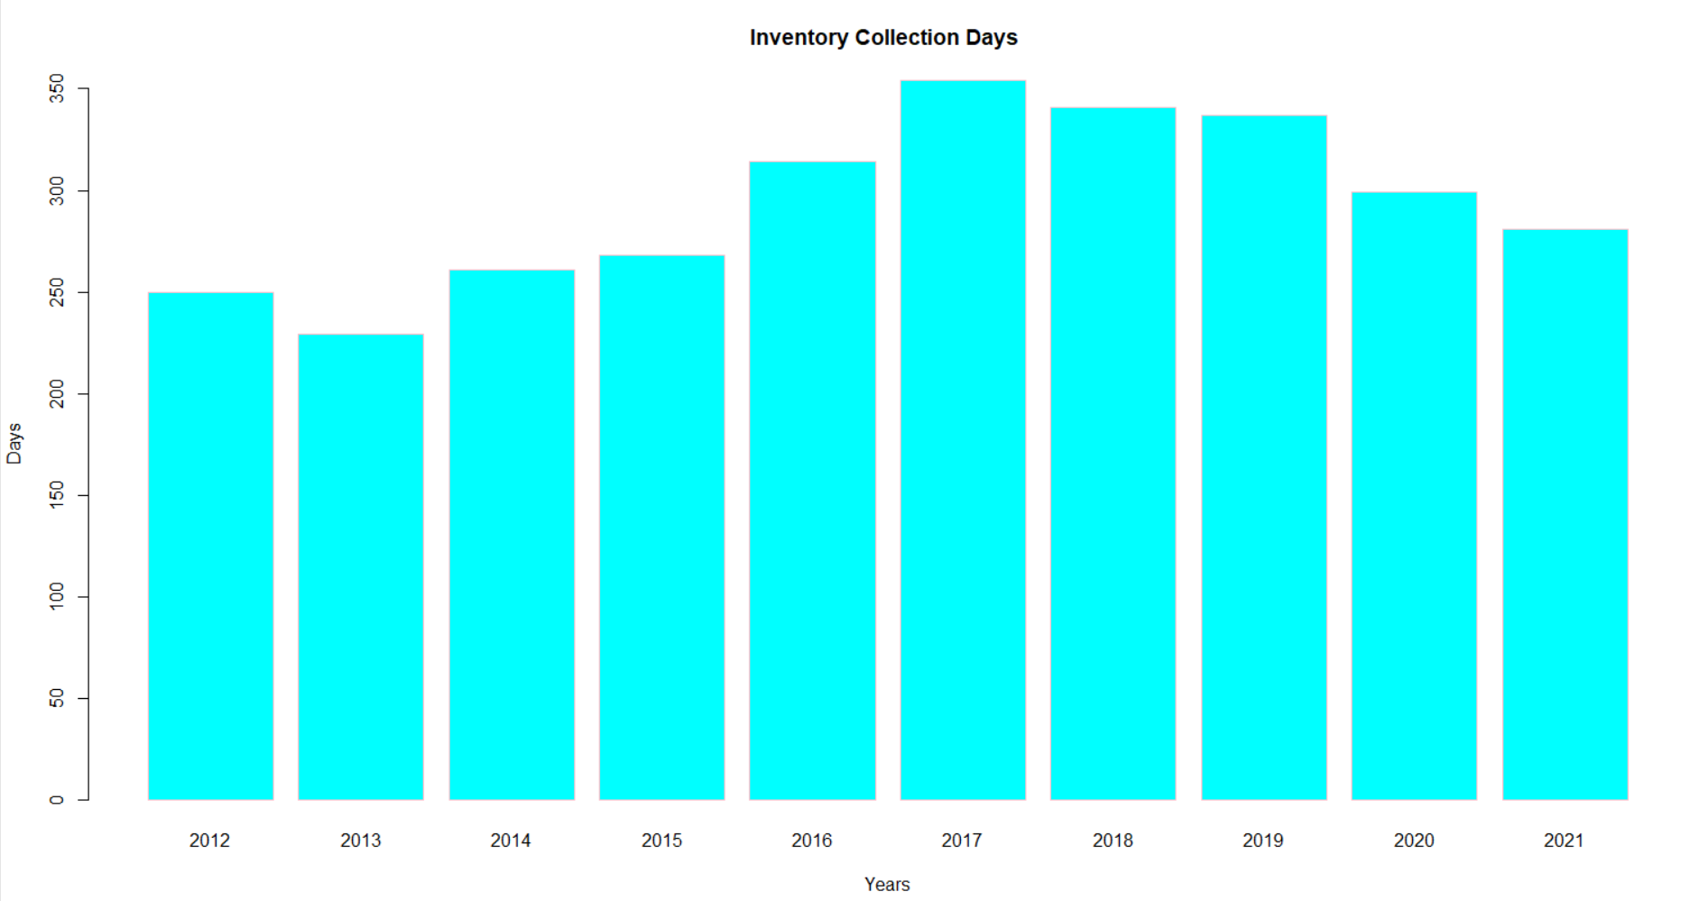

In number of days it takes to get cash or profit from inventory or sales.

Here all years taking more days for an operating cycle ,that means it affects the financial position of company by getting slow rate of income or profit.

Year 2017 takes more than 300 days then company will be in financially low and struggle.

Profitability Ratio:

Profit Margin:

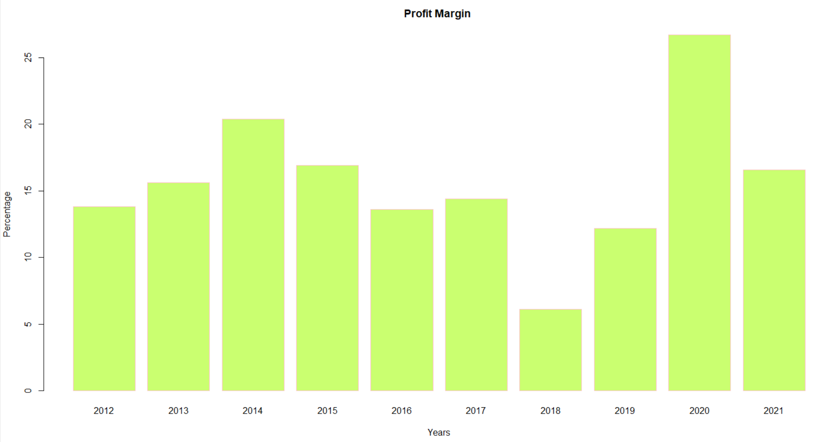

* In 2020 ,it is high means company has more cash available to distribute to shareholders or invest in new opportunities.
* In 2018 it is very low it cant be able to maintain the company
* In that year
* Overall, it has average profit margin ratios,it is good enough to be a healthy company.

**Asset Turnover Ratio:**

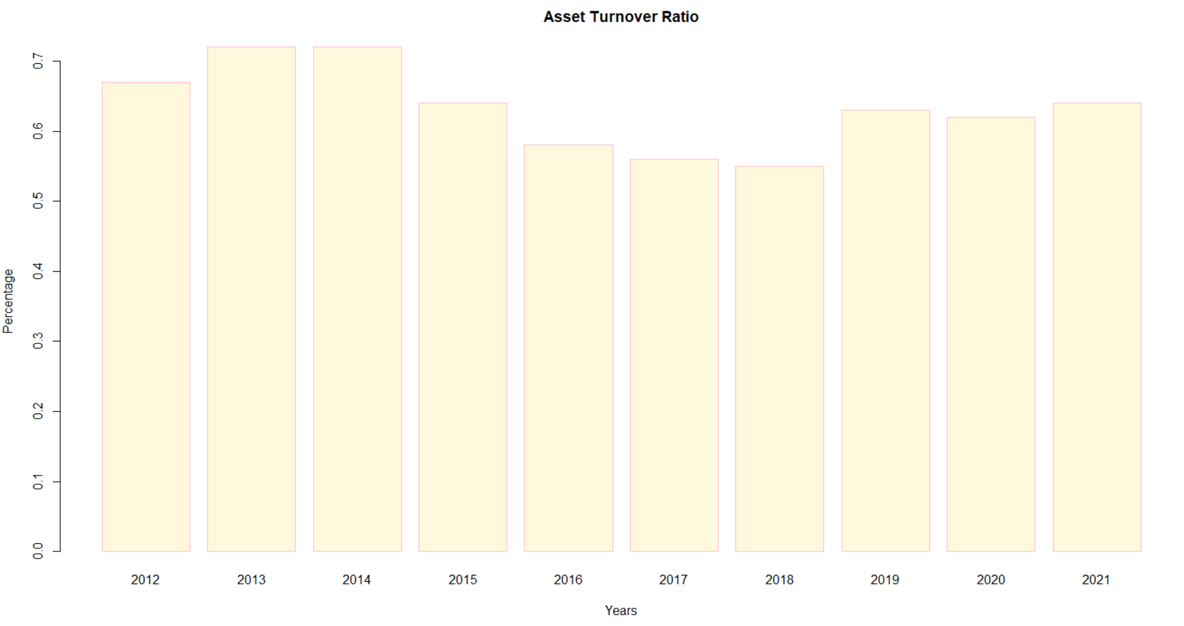

* The ratio measures the efficiency of how well a company uses assets to produce sales.
* In the years 2013,2014 has higher ratio, it is favorable, as it indicates a more efficient use of assets.
* In the years 2017,2018 it has slightly lower ratio indicates the company is not using its assets as efficiently.

**Return on Equity:**

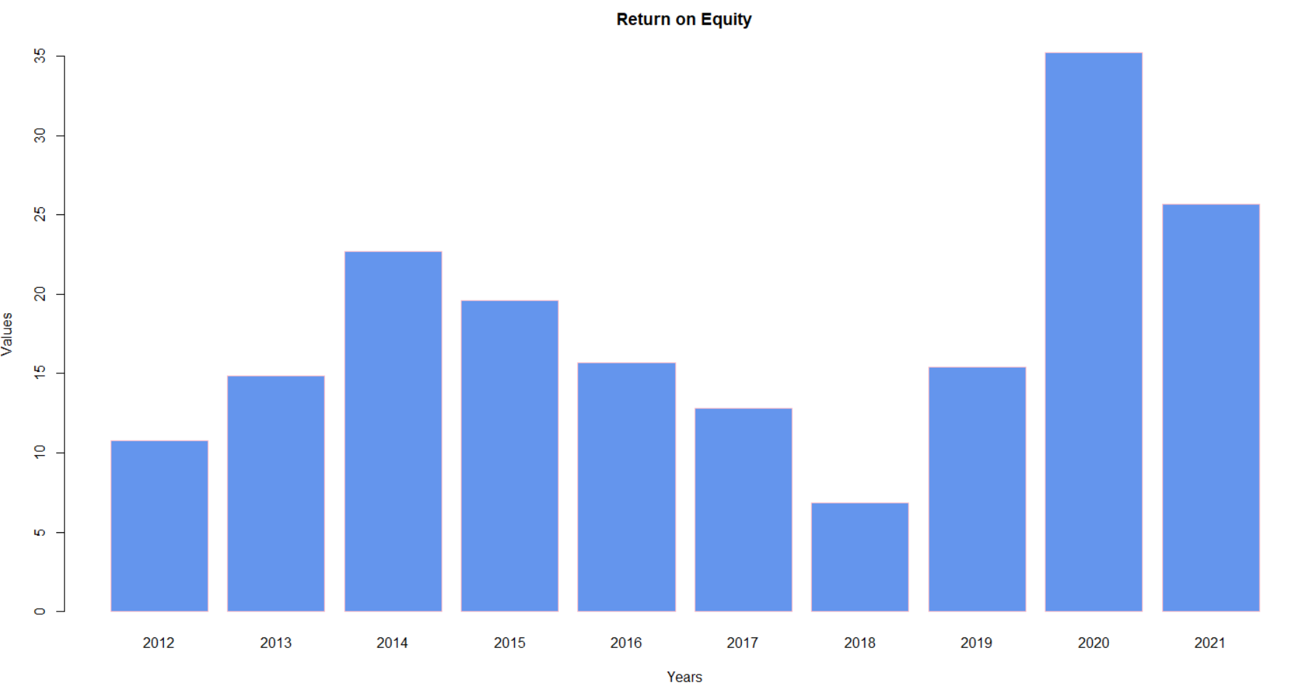

* Return on equity signifies how good the company is in generating returns on the investment it received from its shareholders.
* Investors generally prefer firms with higher ROEs. Initially it has low REOs but gradually it increases now it is good.
* A higher percentage indicates a company is more effective at generating profit from its existing assets. Likewise, a company that sees increases in its ROE over time is likely getting more efficient.

**Return on Assets:**

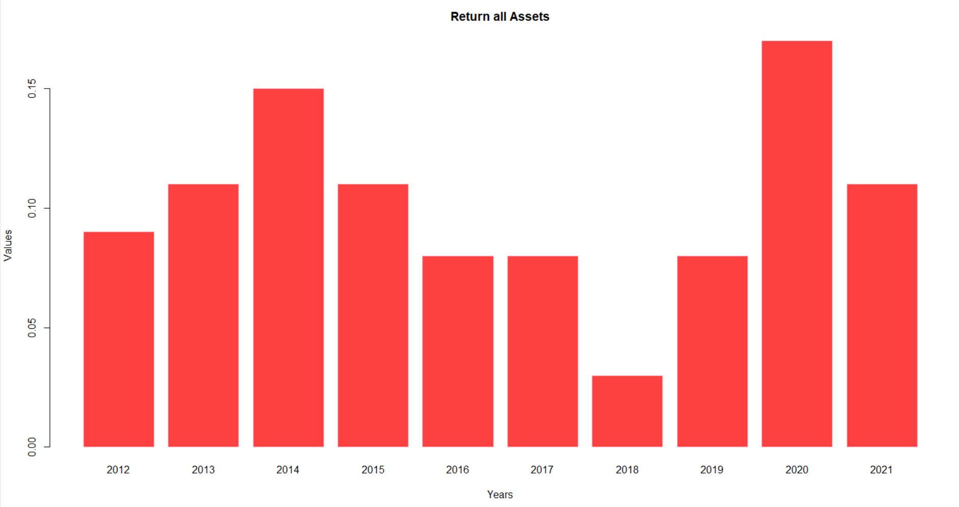

* The higher the ROA number, the better, because the company is able to earn more money with a smaller investment.
* It has higher ROA in 2020 ,means more asset efficiency.
* For the ten years it is low so it effects the income of the company and its financial position,it must get a higher investment for earing income.
* Because it has very low assets.

**SOLVENCY RATIOS:**

**Debt to Equity Ratio:**

* In 2013,2021,2022 value is below 1 that means the company has more short-term debts than cash.
* In 2019 value is high means the company has enough cash to cover its debts.
* From the beow graph ratio is comparitively vey low , lower debt to equity ratio means the company primarily relies on wholly-owned funds to leverage its finances

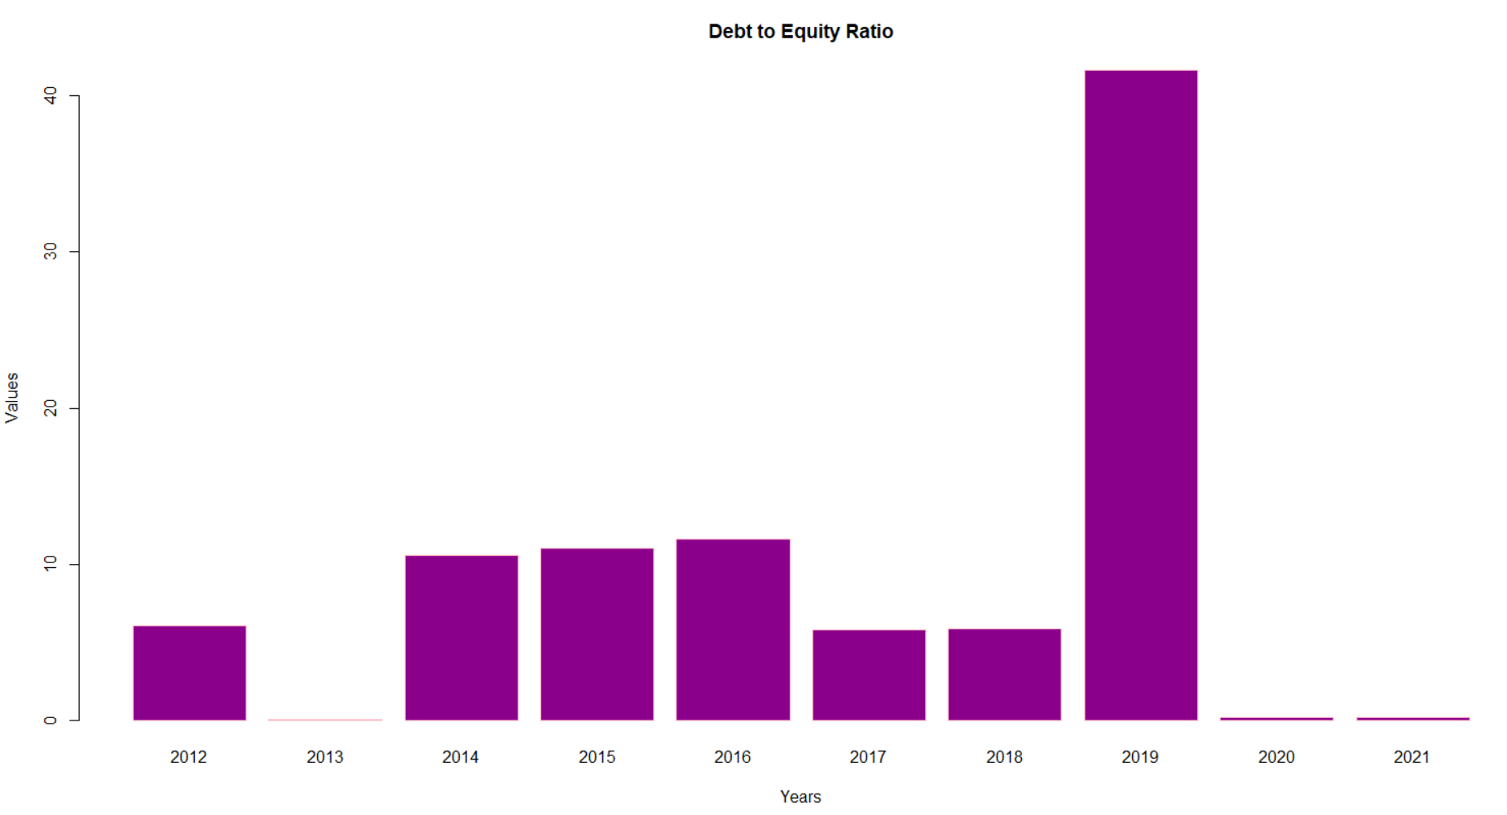

**Solvency Ratio:**

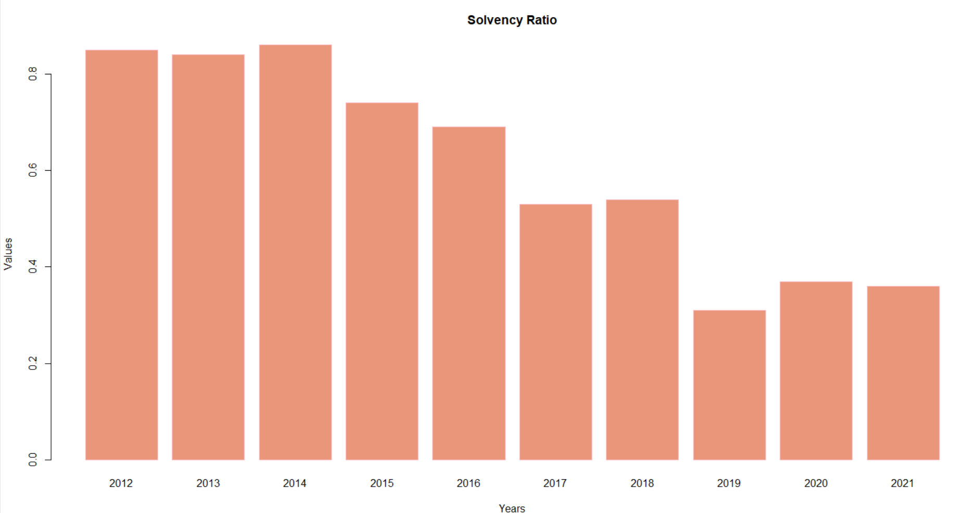

* It enables us to determine whether the company can meet its financial obligations in the long term.
* A high solvency ratio in the year 2012 to 2016 shows that a company can remain financially stable in the long term.
* After that it is falling, but a ideal solvency ratio more than 20% it regarded as financially healthy so it is good enough.

**Properietory Ratio:**

In the first 5 years ,it has A high proprietary ratio indicates that a business is in a strong position and provides relief to creditors.

After that graph is suddenly falldown for the next 5 years,it shows the dependence of the company on the debt financing in order to run its business.

It also indicates that creditors will lose interest for providing finance to such a company. Interest rates will become high and there is also a high risk of bankruptcy.

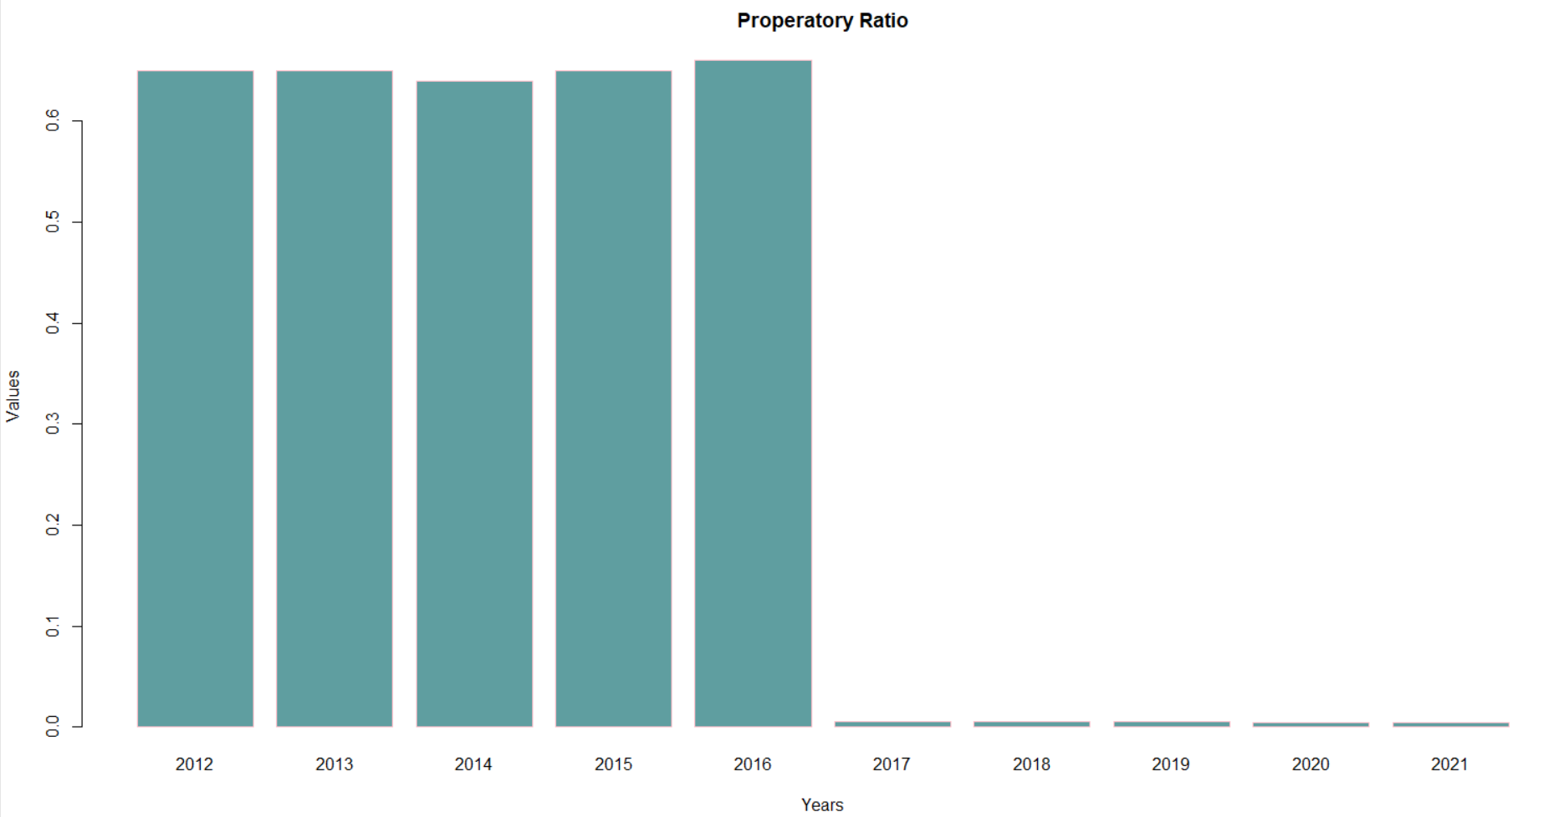

**Fixed Asset Ratio**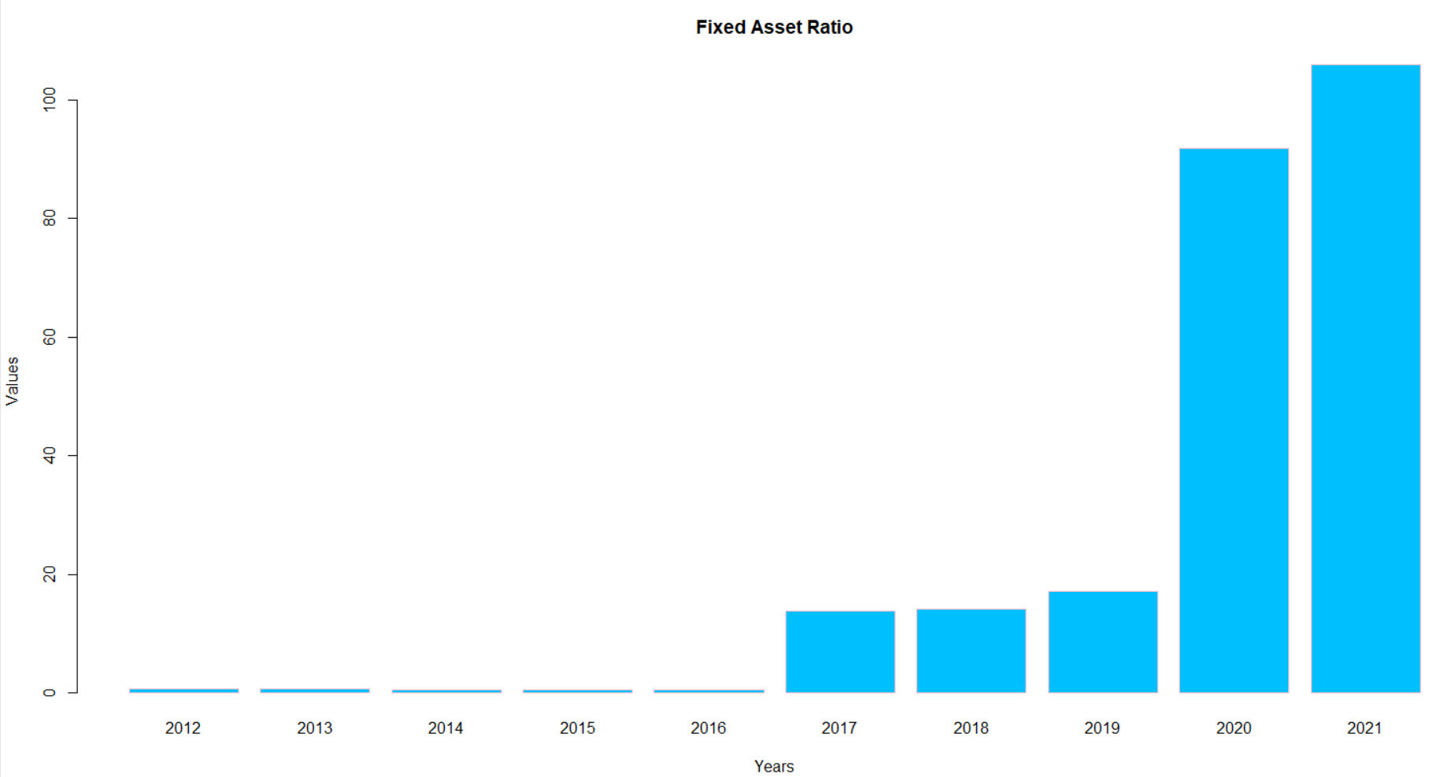

* The fixed asset turnover ratio reveals how efficient a company is at generating sales from its existing fixed assets
* For the year 2020 and 2021 ,it has higher ratio  implies that management is using its fixed assets more effectively.
* If it is very less like as the years 2012 to 2016,its not good for the company as the total assets cannot produce enough revenue at the end of the year.

**PE Ratio:**

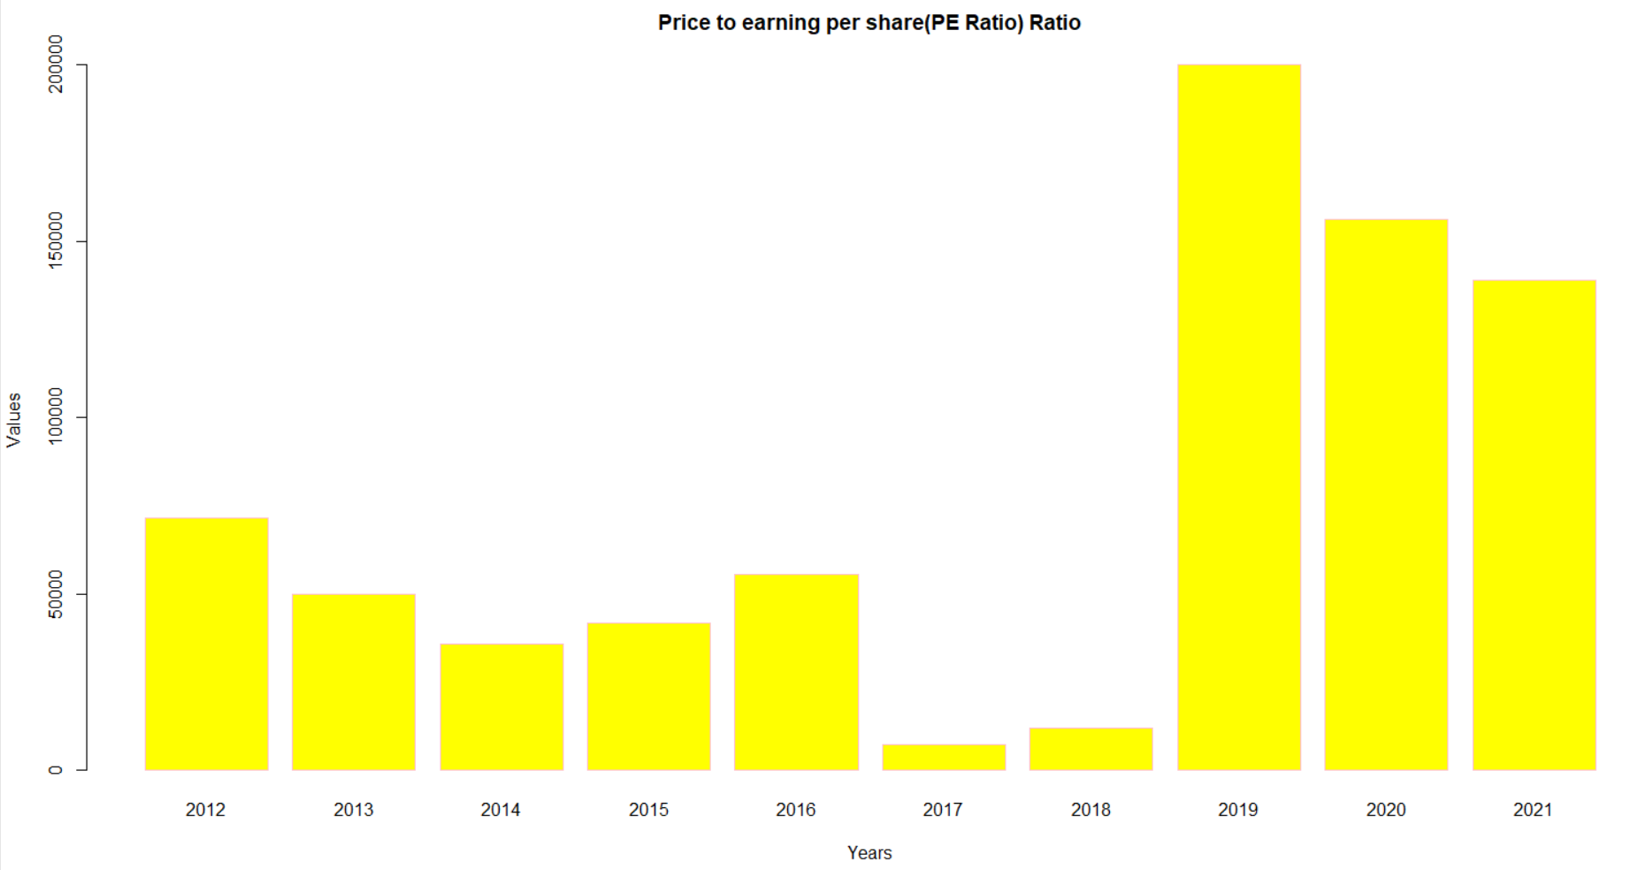

The PE ratio is very useful in making investment decisions.

As the years 2019,2020,2021 has high PE means that a stock is expensive and its price may fall in the future.

As the years 2017 and 2018 has low PE means that a stock is cheap and its price may rise in the future.

**Dividend Yield:**

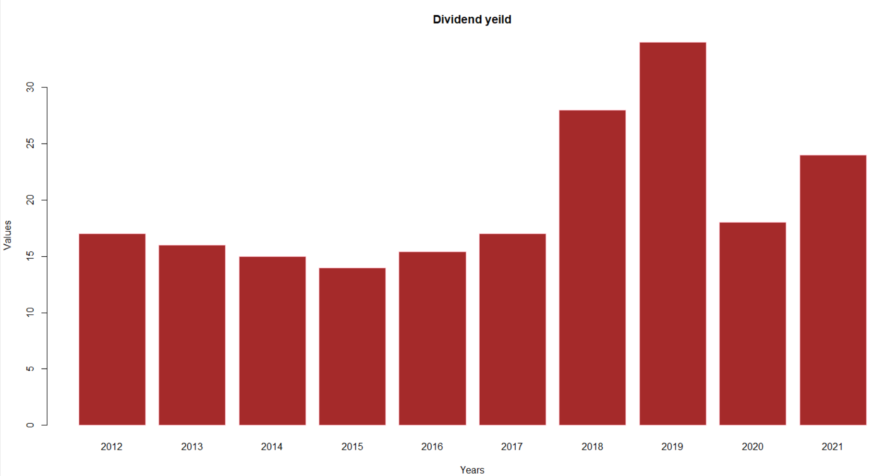

This represents the risk inherently involved in investing in the company.

**For the year 2019 has high dividend yield stocks that** indicate how much a firm pays out in dividends about its market share price each year.

Good dividend yields from 2 to 6 percent ,from the graph we can tell that company is in good state.

**4.GLENMARK**

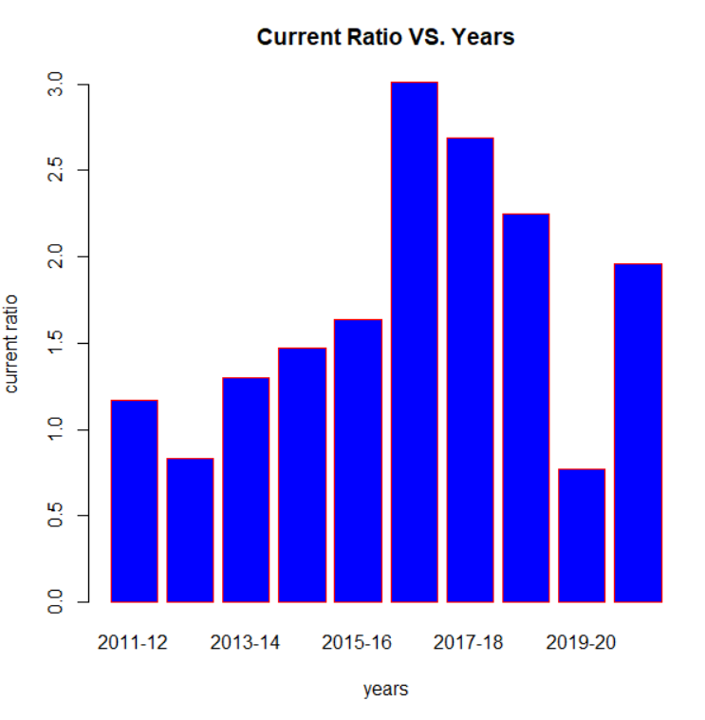

* The current ratio indicates the ability of a company to generate cash from  [current assets](https://efinancemanagement.com/working-capital-financing/current-assets-key-features) to pay [current liabilities](https://efinancemanagement.com/financial-accounting/current-liability-meaning-accounting), which become due in the short term.
* A ideal current Ratio is 2:1 ,if it is 1:1 then it is impossible to get profit.
* Years 2017,2018,2019 and 2021 having more than 2 and year 2017 has higher current ratio that says their financial position is better by getting more profit.
* The low current ratio is a direct sign of a high risk of bankruptcy, and too high would impact the profits adversely.

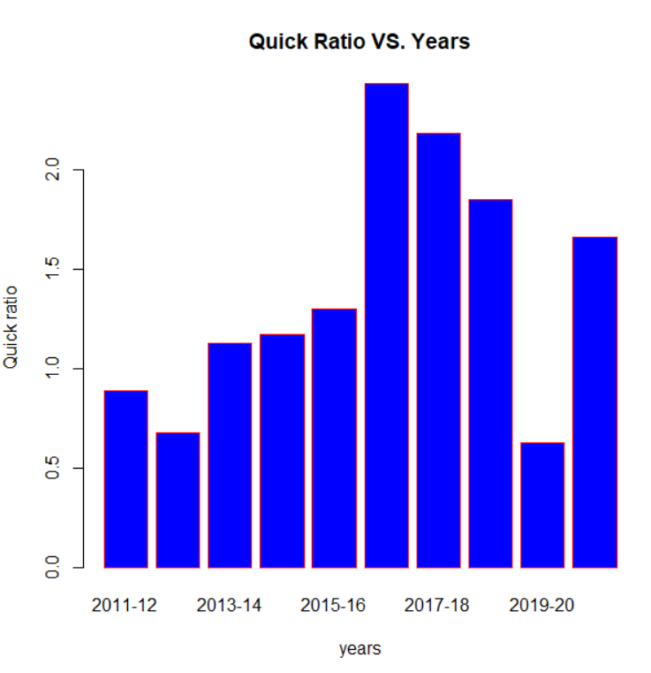

* The quick ratio measures a company's capacity to pay its current liabilities without

needing to sell its inventory or obtain additional financing.

* The ideal standard ratio is 1: 1. Here all are above 1, so these are good enough.
* 2017 has higher ratio that can say that better a company’s liquidity and financial health.
* In 2013,2020 it is low compared to remaining. The lower the ratio, the more likely

the company will struggle with paying debts. But here it is ok because it is more than 1.

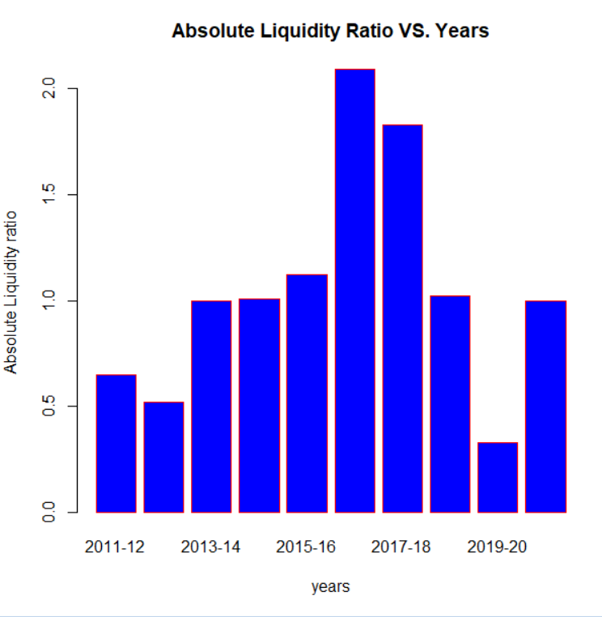

* An acid ratio test, same as a quick ratio, measures the ability of a company to use their short-term assets to cover their immediate liabilities.
* An acid test ration greater than 1 is considered healthy and is important for external stakeholders like creditors, lenders, [investors](https://www.freshbooks.com/hub/leadership/find-investors-small-business) and capitalists.
* So we can say from graph this company has good acit test ratios. If a company has a ratio of less than 1, they cannot currently fully pay back its current liabilities.
* A high or increasing acid test ratio as in year 2017 indicates a company has faster inventory turnover and cash conversion cycles than the other years.

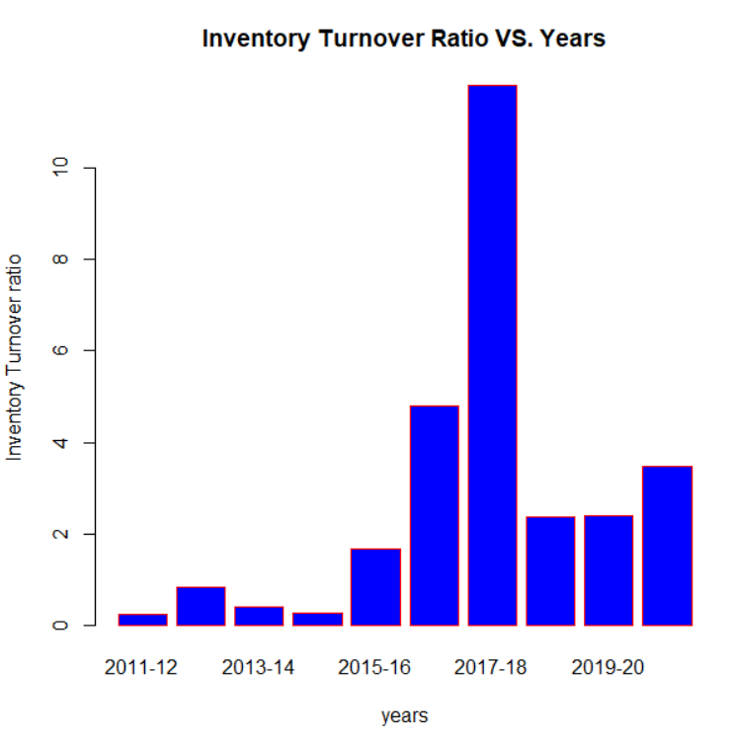

* Inventory turnover is important because it highlights how efficient a company is at converting inventory into final sales and cash.
* From year 2018 to 2021 the ratio is falling that means company holding more stock which will increases carriage costs. Profit will not come from this rate of inventory ratio.
* It is increasing from the 2015 to 2018,that means it will able to convert inventory and get profit in a little bit faster rate than remaining years.

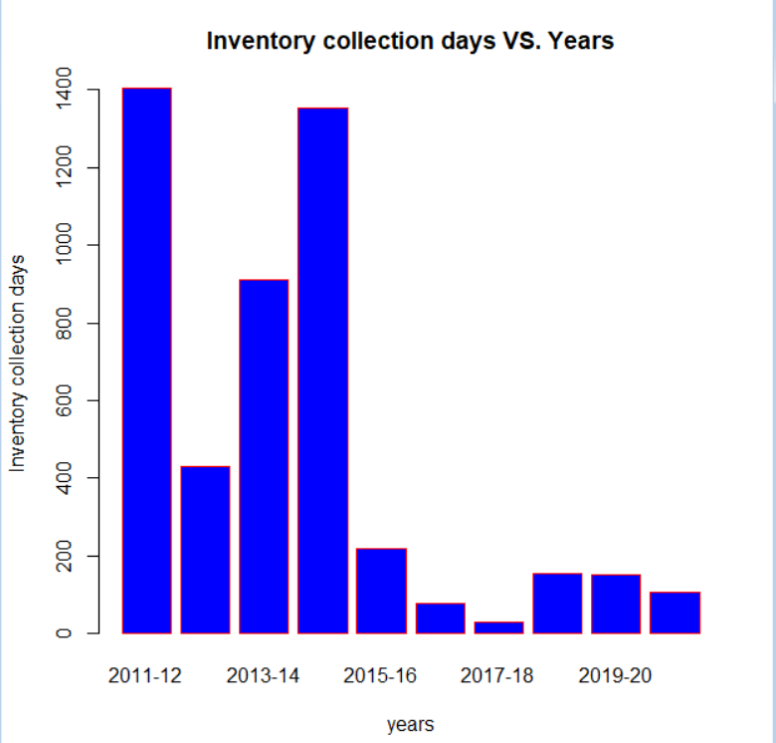

In number of days it takes to get cash or profit from inventory or sales.

Here all years taking more days for an operating cycle ,that means it affects the financial position of company by getting slow rate of income or profit.

Until Year 2015 takes more than 300 days then company will be in financially low and struggle.

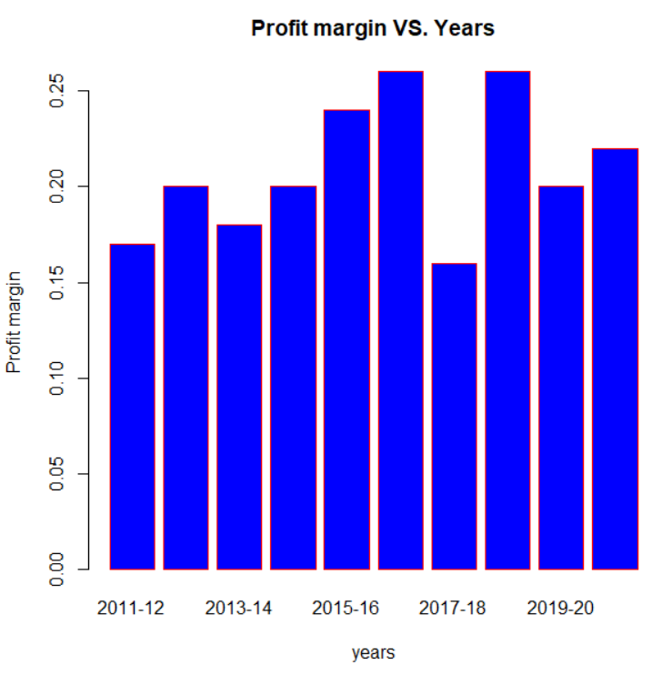

* In 2017 and 2019, it is high means company has more cash available to distribute to shareholders or invest in new opportunities.
* In 2018 it is very low it can’t be able to maintain the company
* In that year, overall it has average profit margin ratios, it is good enough to be a healthy company.

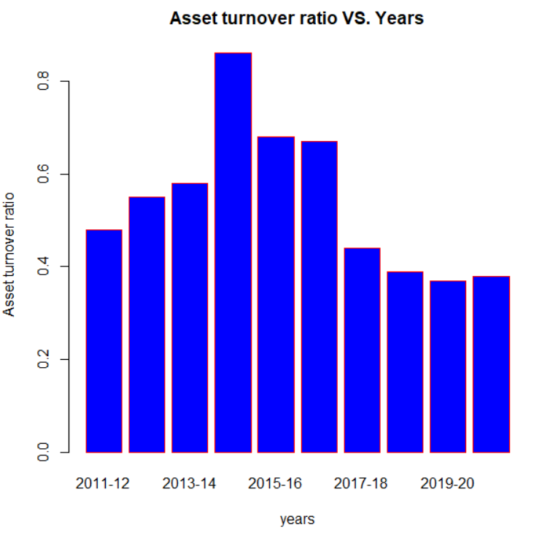

* The ratio measures the efficiency of how well a company uses assets to produce sales.
* In the year 2015, has higher ratio, it is favourable, as it indicates a more efficient use of assets.
* In the years 2018,2019,2020 and 2021 it has slightly lower ratio indicates the company is not using its assets as efficiently.

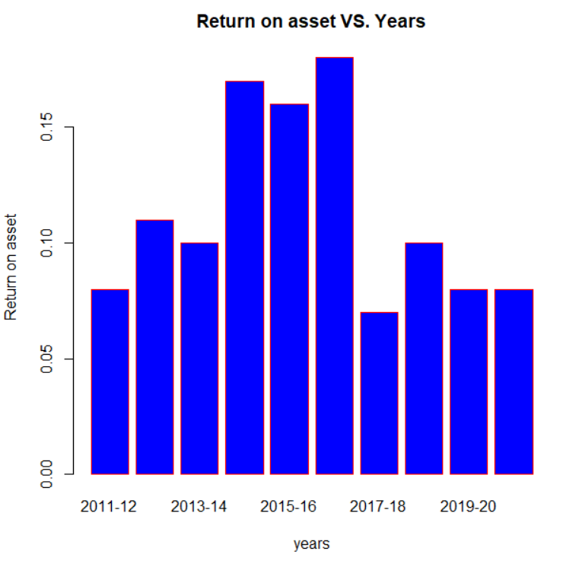

* The higher the ROA number, the better, because the company is able to earn more money with a smaller investment.
* It has higher ROA in 2017, means more asset efficiency.
* For the ten years it is low so it effects the income of the company and its financial position, it must get a higher investment for earing income.
* Because it has very low assets.

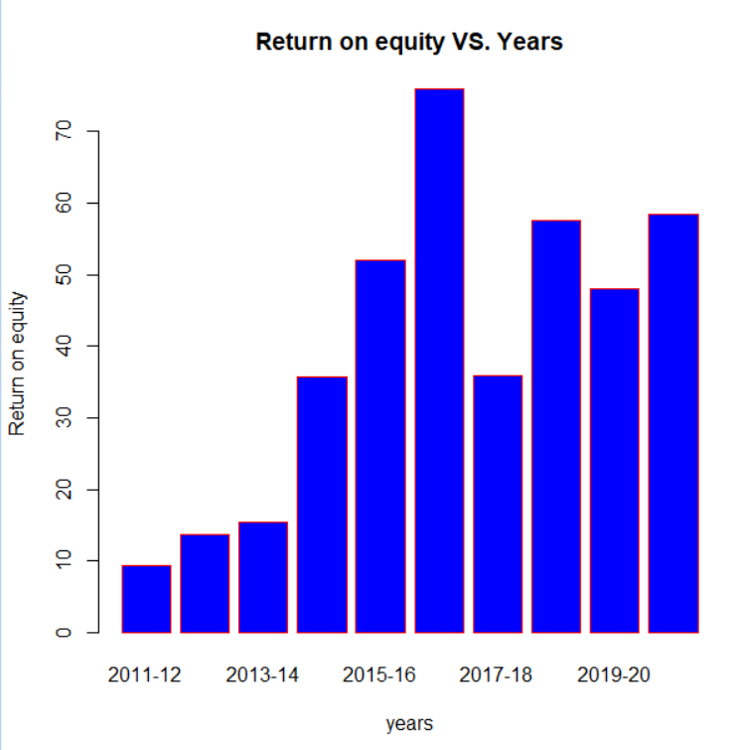

* Return on equity signifies how good the company is in generating returns on the investment it received from its shareholders.
* Investors generally prefer firms with higher ROEs. Initially it has low REOs but gradually it increases now it is good.
* A higher percentage indicates a company is more effective at generating profit from its existing assets. Likewise, a company that sees increases in its ROE over time is likely getting more efficient.

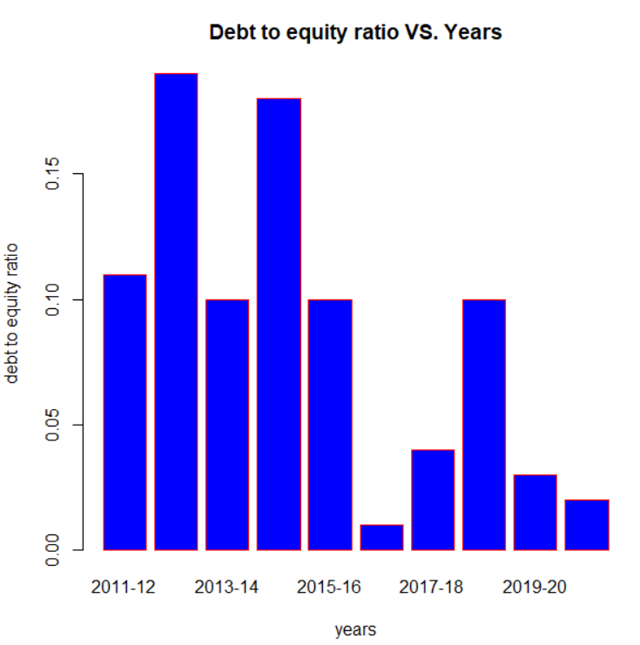

* In 2017, 2018, 2020, 2021 value is below 1 that means the company has more short-term debts than cash.
* In 2013 value is high means the company has enough cash to cover its debts.
* From the beow graph ratio is comparitively vey low , lower debt to equity ratio means the company primarily relies on wholly-owned funds to leverage its finances

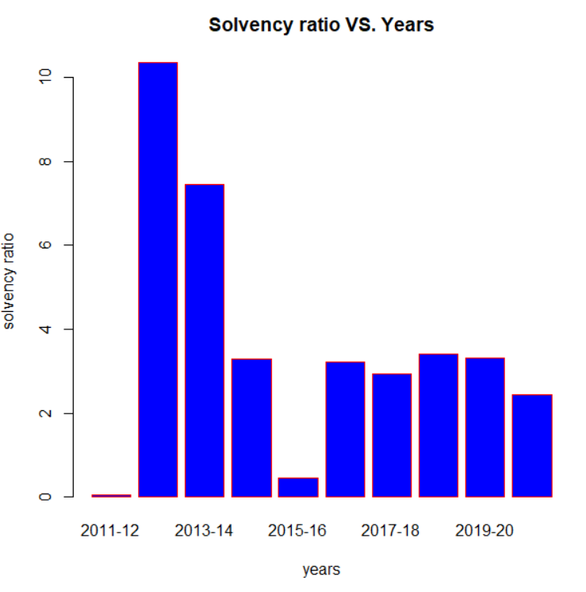

* It enables us to determine whether the company can meet its financial obligations in the long term.
* A high solvency ratio in the year 2013 shows that a company can remain financially stable in the long term.
* After that it is falling, but a ideal solvency ratio more than 20% it regarded as financially healthy so it is good enough.

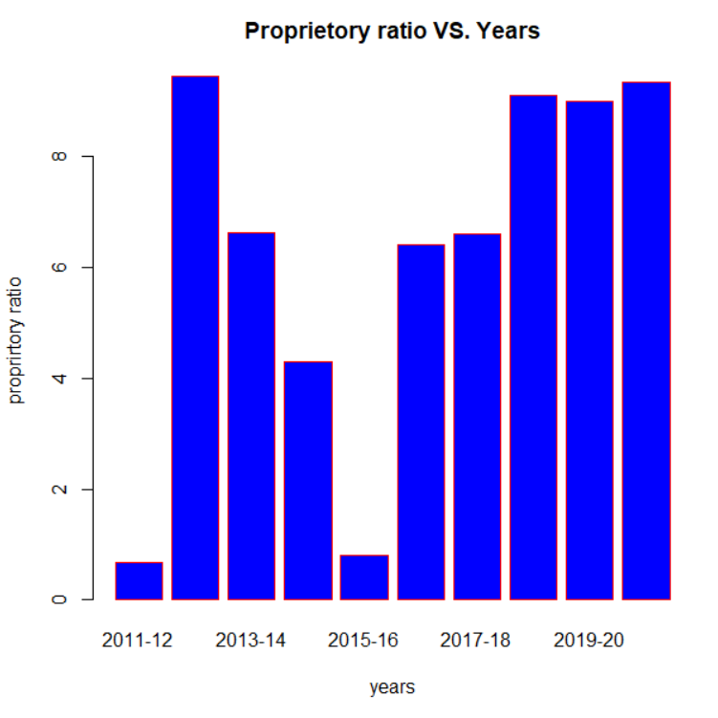

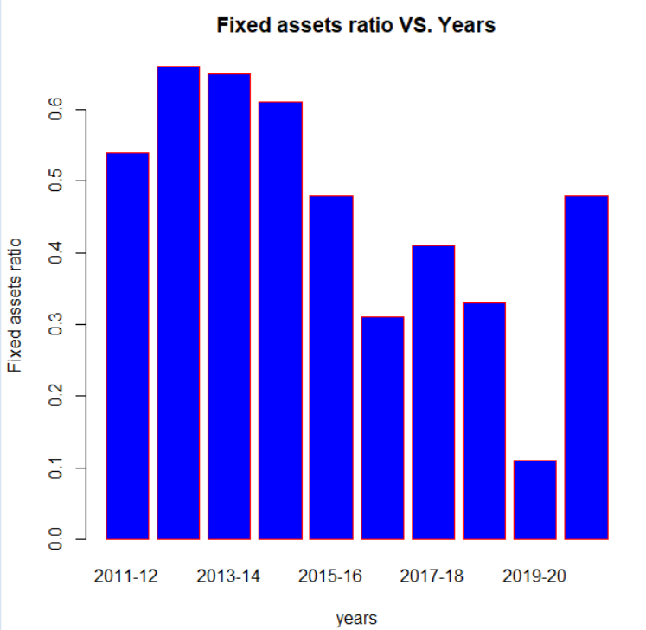

**5.TORRENT PHARMACEUTICALS**

LIQUIDITY RATIOS:

Current Ra o:

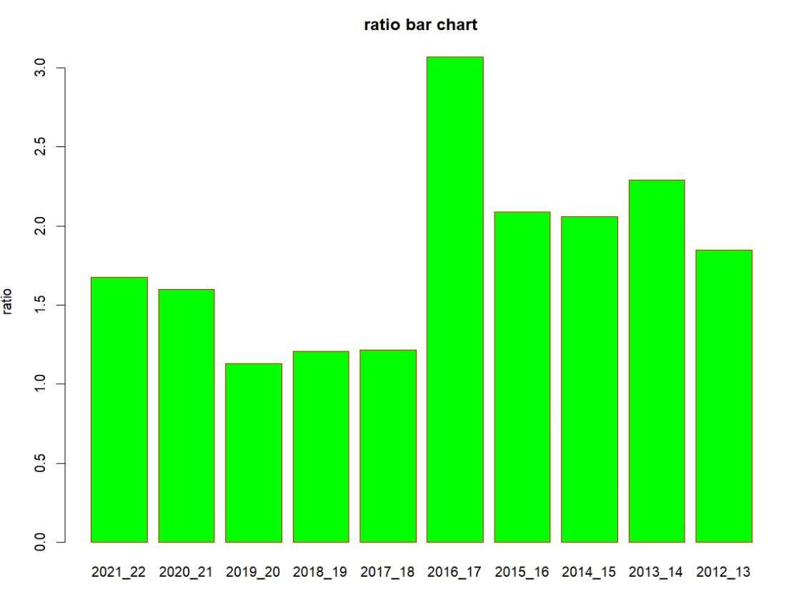

* The current ratio indicates the ability of a company to generate cash from current assets to pay current liabilities, which become due in the short term.
* A ideal current Ratio is 2:1 ,if it is 1:1 then it is impossible to get profit.
* In the year 2016-17 get highest current ratio. All the years it shows some what better, but crossing 2:1 in 4 years
* The low current ratio is a direct sign of a high risk of bankruptcy, and too high would impact the profits adversely.

Quick Ra o:

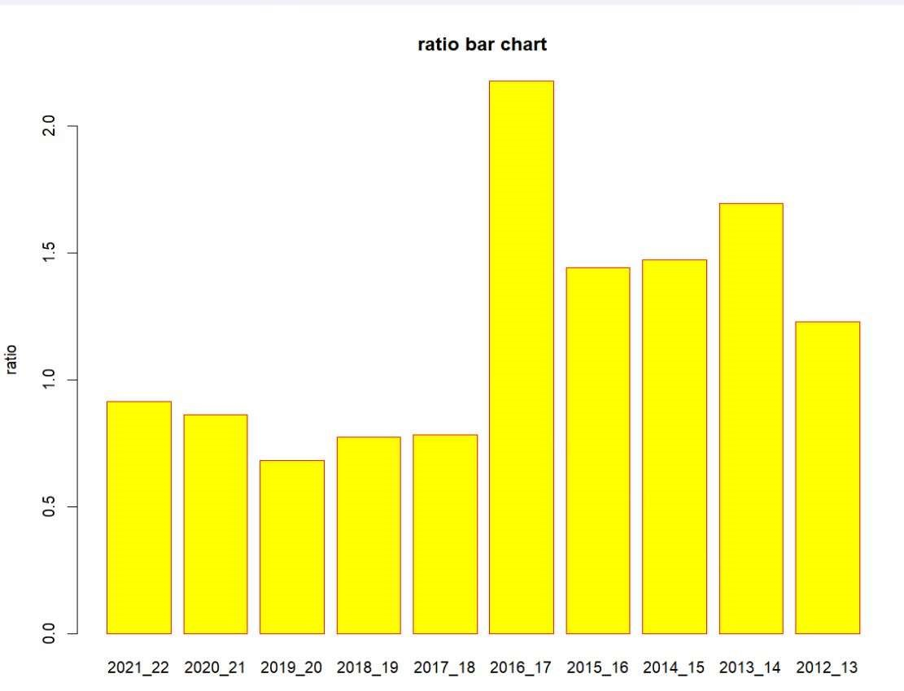

* The quick ratio measures a company's capacity to pay its current liabilities without needing to sell its inventory or obtain additional financing.
* The ideal standard ratio is 1: 1. Here all are above 1, so these are good enough.
* 2016-17 has higher ratio that can say that better a company’s liquidity and financial health.
* In 2019-20,2018-19,2017-18 it is low compared to remaining. The lower the ratio, the more likely

the company will struggle with paying debts.

Acid test ratio :

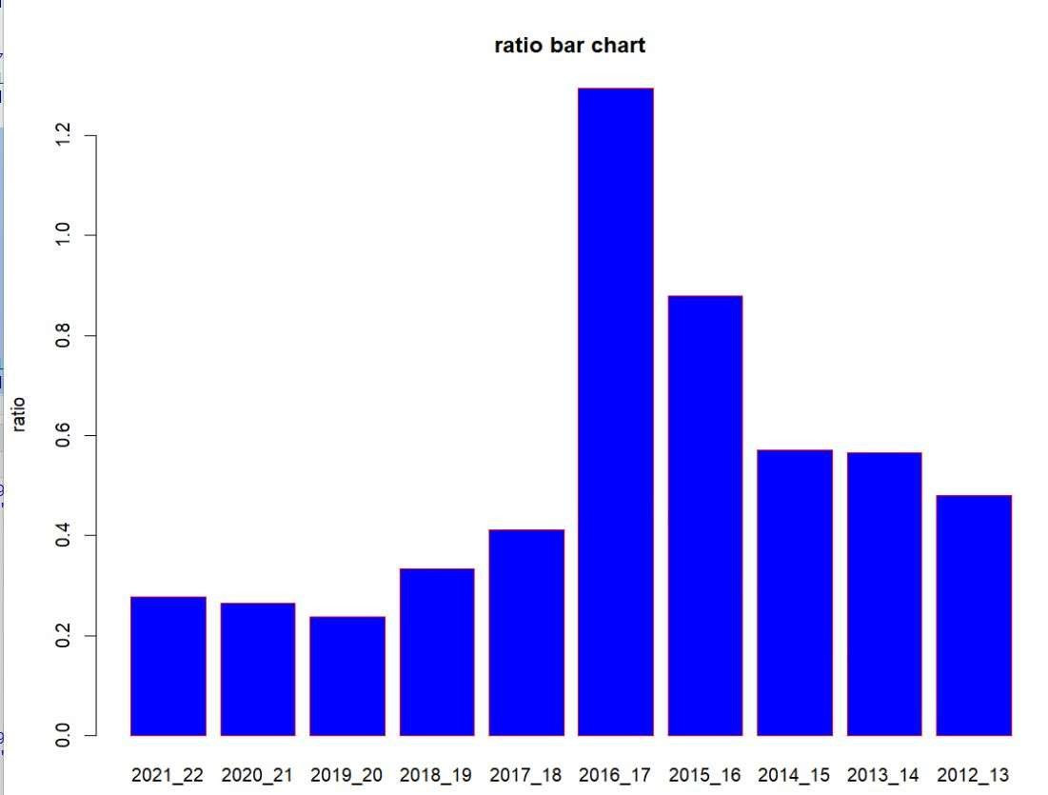

* An acid ratio test, same as a quick ratio, measures the ability of a company to use their short-term assets to cover their immediate liabilities.
* An acid test ration greater than 1 is considered healthy and is important for external stakeholders like creditors, lenders, investors and capitalists.
* So we can say from graph this company has not healthy acid test ratios. If a company has a ratio of less than 1, they cannot currently fully pay back its current liabilities.

A high or increasing acid test ratio as in year 2016-17 indicates a company has faster inventory turnover and cash conversion cycles than the other years.

Inventory Turnover Ra o:

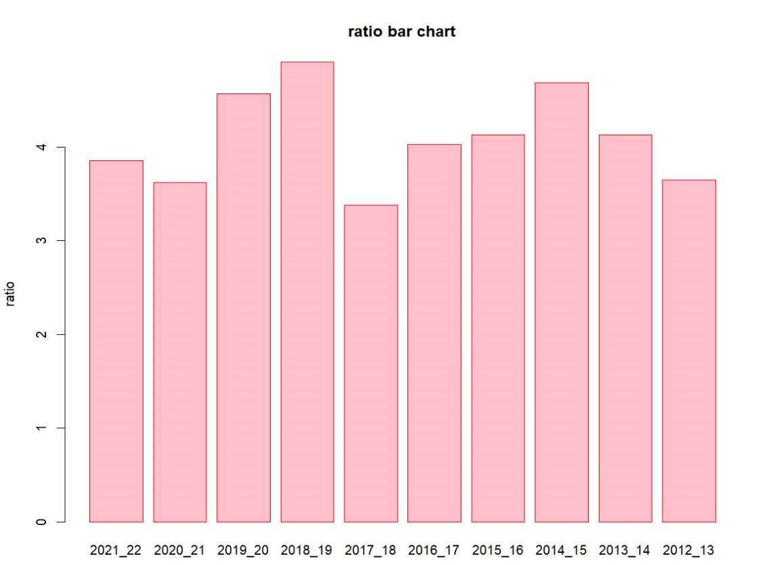

* Inventory turnover is important because it highlights how efficient a company is at converting inventory into final sales and cash.
* From the graph we can say that inventory turn over ratio is good and the company is good in converting inventories to cash in the year 2018-19
* It is increasing and decreasing in specific yrs but not sudden decreases

Inventory Collec on Days:

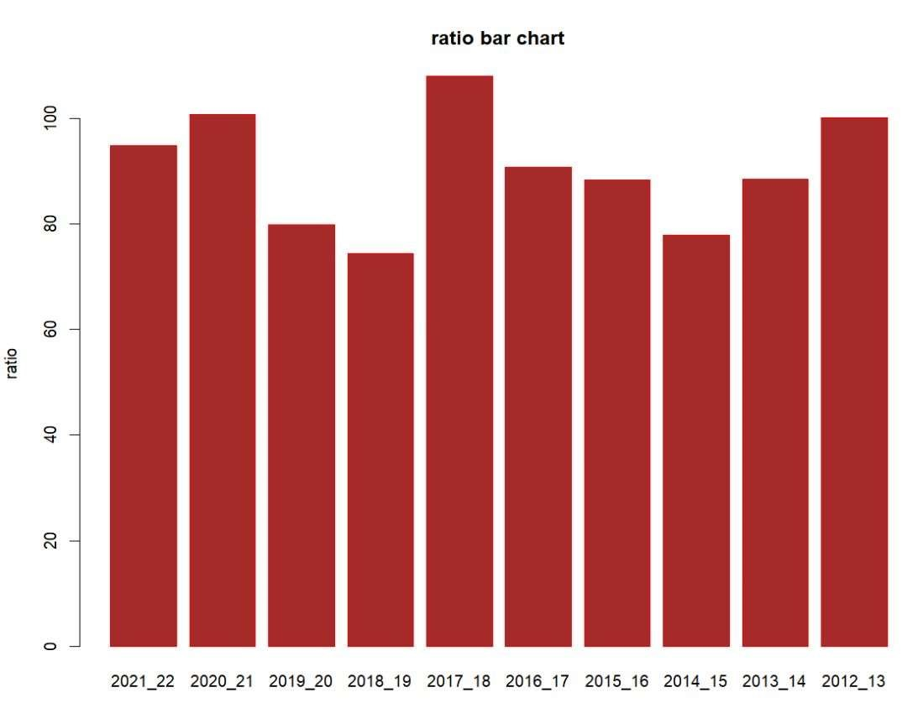

In number of days it takes to get cash or profit from inventory or sales.

Here all years taking less days for an opera ng cycle ,that means it affects the financial posi on of company by ge ng fast rate of income or profit.

Year 2017_18 takes more than 108 days then company will be in financially low and struggle., All the years, the company can complete operating cycle with in 108 days

Profitability Ra o:

Profit Margin:

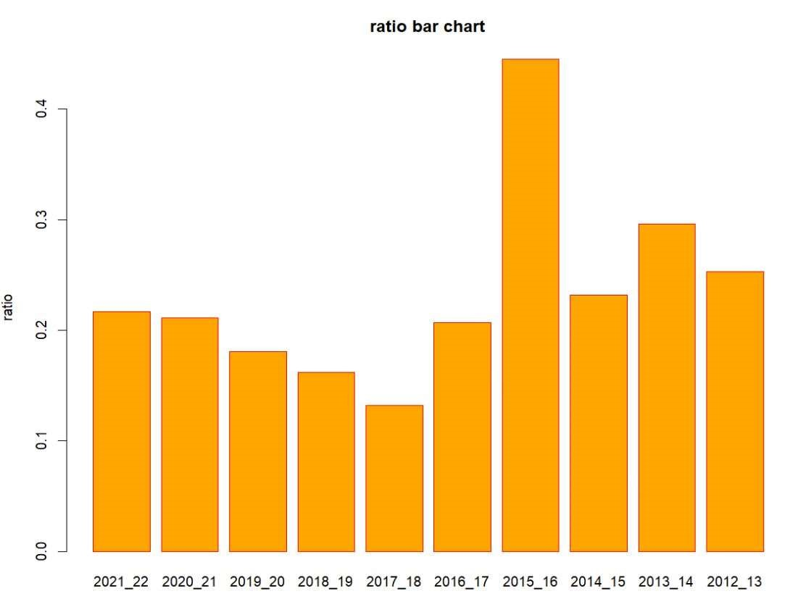

* In 2015-16 ,it is high means company has more cash available to distribute to shareholders or invest in new opportuni es.
* In 2017-18 it is very low it cant be able to maintain the company ➢ In that year

Overall, it has average profit margin ratios,it is good enough to be a healthy company

Asset Turnover Ra o:

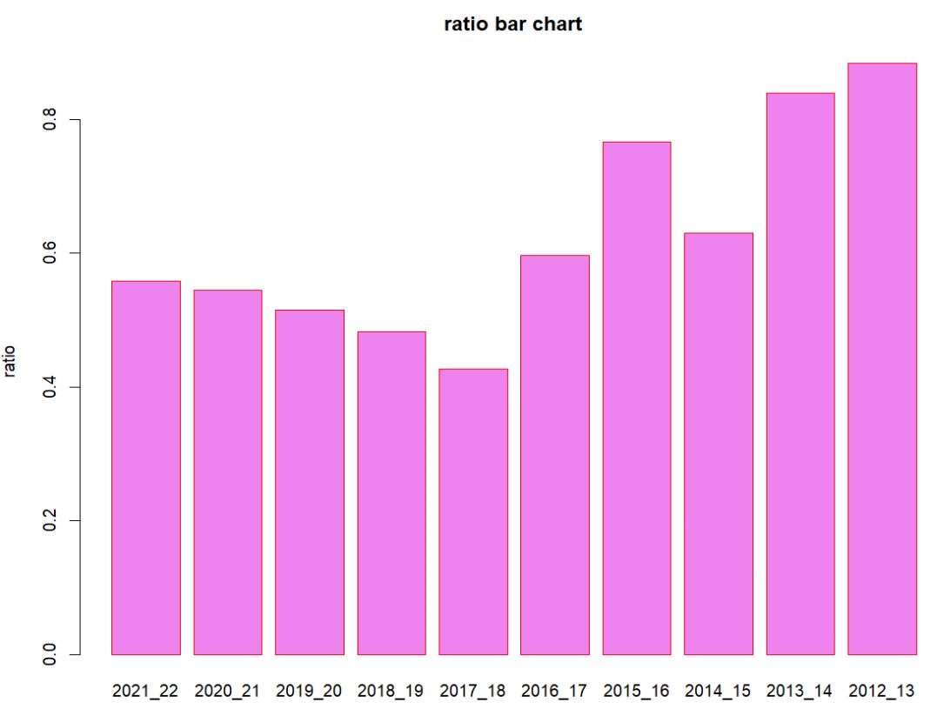

* The ratio measures the efficiency of how well a company uses assets to produce sales.
* In the years 2013,2014 has higher ratio, it is favorable, as it indicates a more efficient use of assets.
* In the years 2017,2018 it has slightly lower ratio indicates the company is not using its assets as efficiently.

Return on Equity

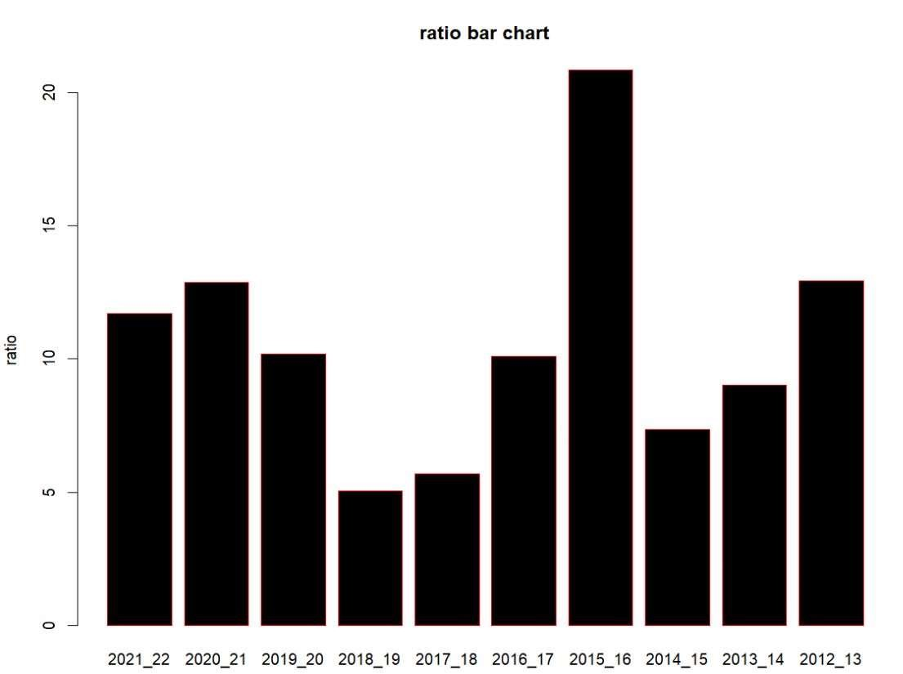

* Return on equity signifies how good the company is in generating returns on the investment it received from its shareholders.
* Investors generally prefer firms with higher ROEs. Initially it has low REOs but gradually it increases now it is good.
* A higher percentage indicates a company is more effective at generating profit from its existing assets. Likewise, a company that sees increases in its ROE over time is likely getting more efficient.

Return on Assets:

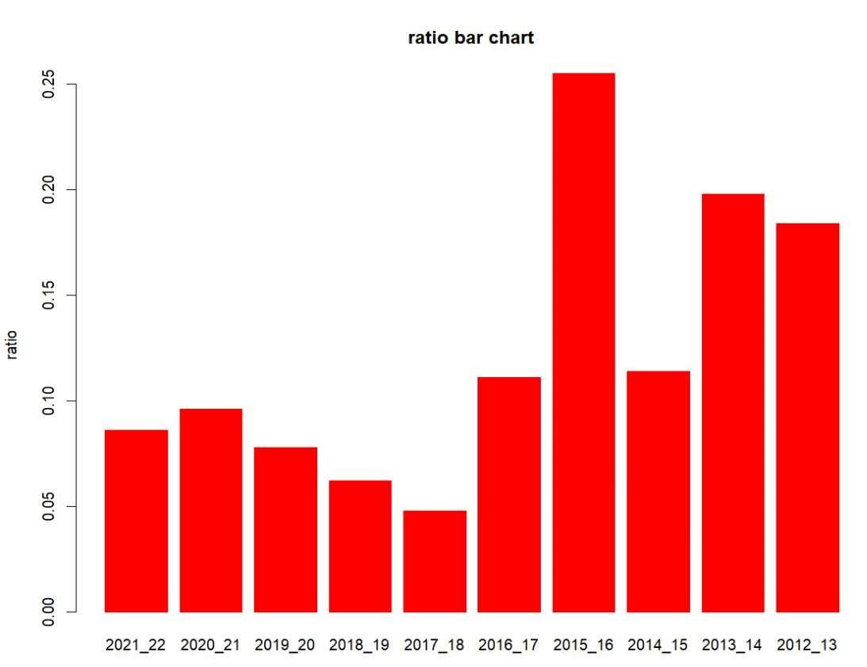

* The higher the ROA number, the better, because the company is able to earn more money with a smaller investment.
* It has higher ROA in 2015-16 ,means more asset efficiency.
* For the ten years it is low so it effects the income of the company and its financial posi on,it must get a higher investment for earing income.
* For ini al five years it earn more profit with less asssets,but a er it started sudden fall down
* Because it has very low assets.

SOLVENCY RATIOS:

Debt to Equity Ra o:

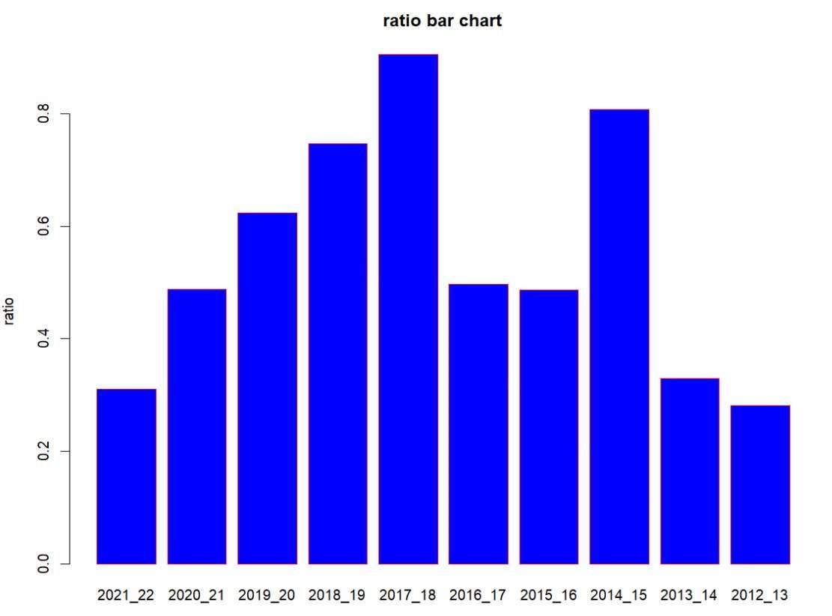

* ALL the years value is below 1 that means the company has more shortterm debts than cash.
* In 2019 value is high, but the company has enough cash to cover its debts

Solvency Ra o:

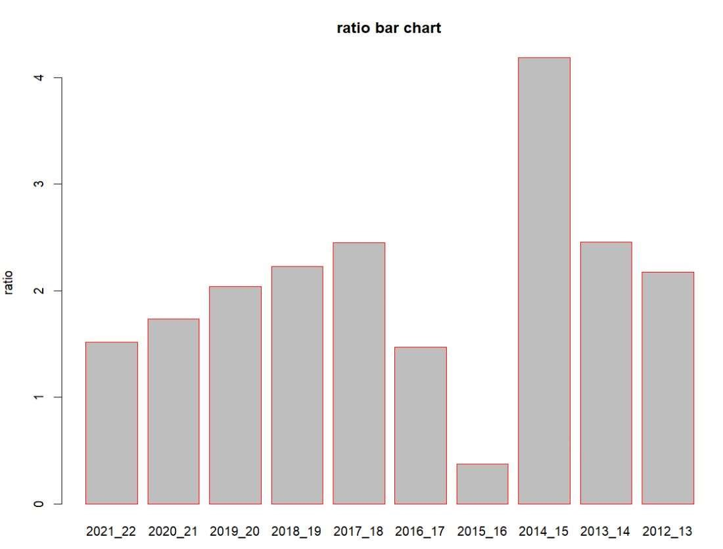

* It enables us to determine whether the company can meet its financial obligations in the long term.

|  |  |  |
| --- | --- | --- |
| A high solvency ratio in the year 2014-15 shows that a company can remain | | |
| financially stable in the long term. |  | |
| After that it is falling, but a ideal solvency ratio more than 20% it regarded as | | |
| financially healthy so it is good enough. | |  |

➢

➢

Propratory Ra o:

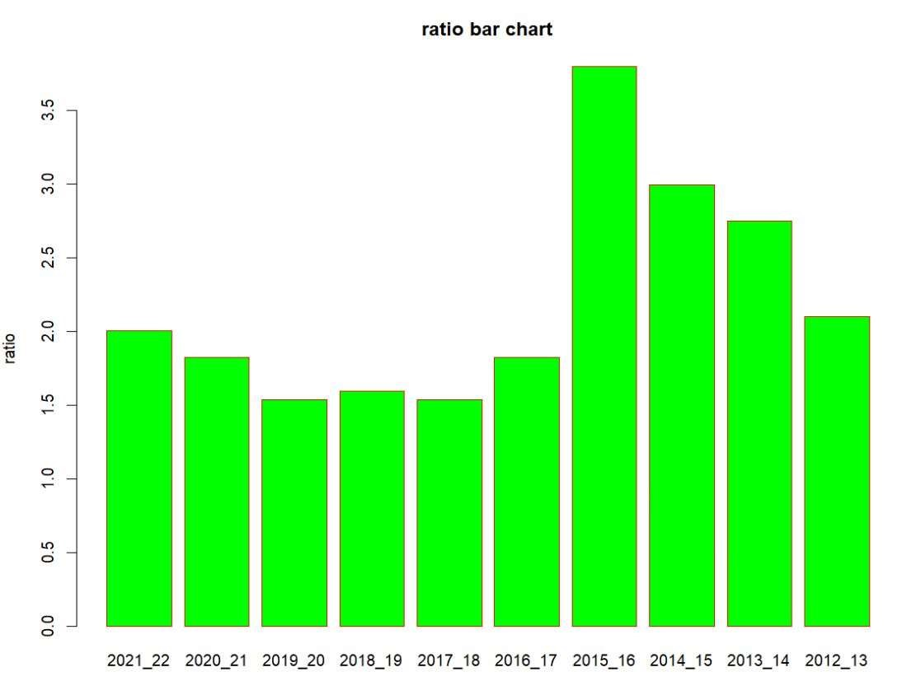

FIXED ASSET RATIO:

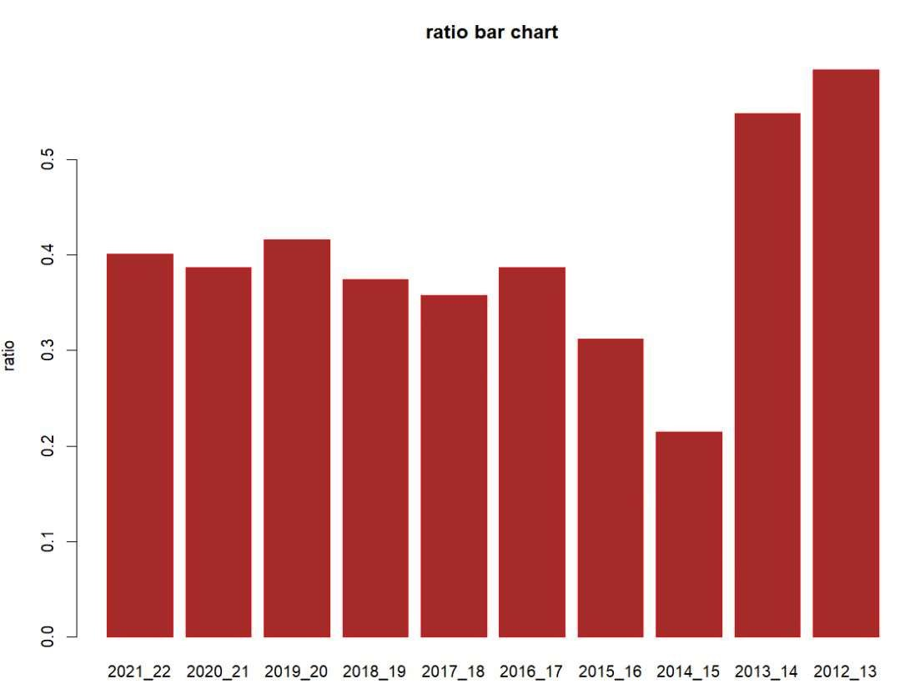

The fixed asset ra o is a financial ra o used to measure a company's ability to finance its fixed assets, such as property, plant, and equipment, through long-term financing. It is calculated by dividing a company's fixed assets by its long-term liabili es.

A high fixed asset ra o indicates that a company has a larger propor on of its fixed assets financed through long-term debt. This can be an indica on of a company's financial stability, as it implies that the company has a stable source of long-term financing to support its fixed assets.

➔ Here all ra os are below 1 so it shows fixed that less performance of the company and management of assets

MARKET RELATED RATIOS

P/E RATIO

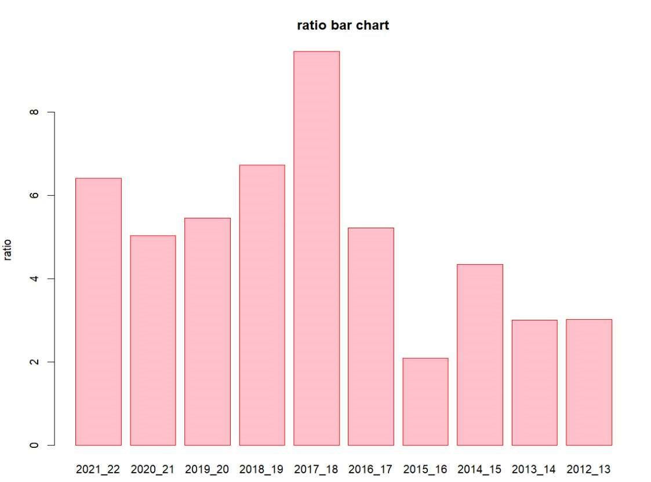

The P/E ra o, or price-to-earnings ra o, is a financial metric used to evaluate the valua on of a company's stock. It is calculated by dividing the current market price of a company's stock by its earnings per share (EPS) over the last twelve months.

A high P/E ra o indicates that investors are willing to pay a premium for each dollar of the company's earnings, which may be a sign that the market has high expecta ons for the company's future growth poten al. On the other hand, a low P/E ra o suggests that the market has lower expecta ons for the company's future growth poten al.

➔ High p/e ra o is not good in 2017-18 the p/e ra o is high and 2015-16 it is very less

**6.SUN PHARMACEUTICALS**

**LIQUIDITY RATIOS:**

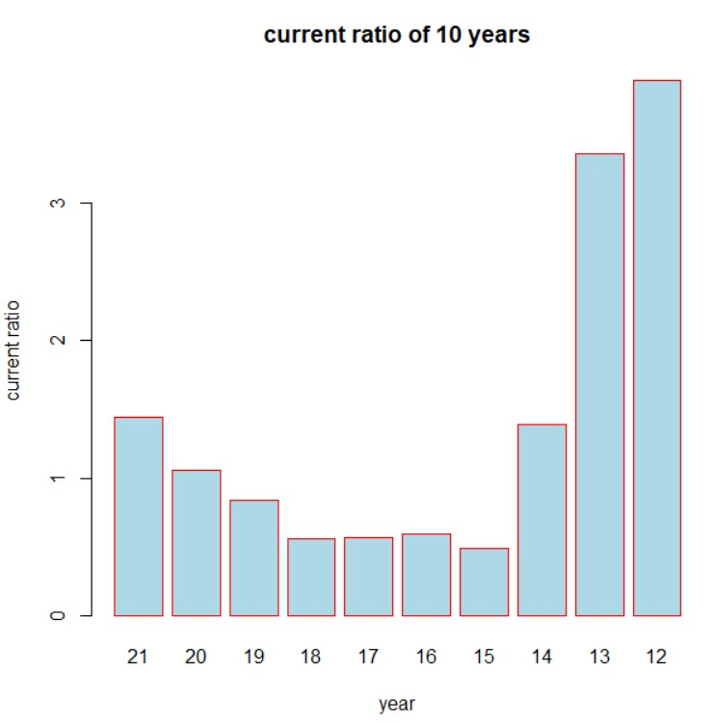

The current ratio indicates the ability of a company to generate cash from current assets to pay its current liabilities. The ideal current ratio is 2:1, if it is 1:1 then it is impossible to get the profit. In the year 2020-2021, 2013-2014, 2012-2013, 2011-2012 are the years which are ease in clearing the debts and liabilities. From 2015 to 2019 the company was in its worst situation that is facing difficulty in paying the debts and liabilities.

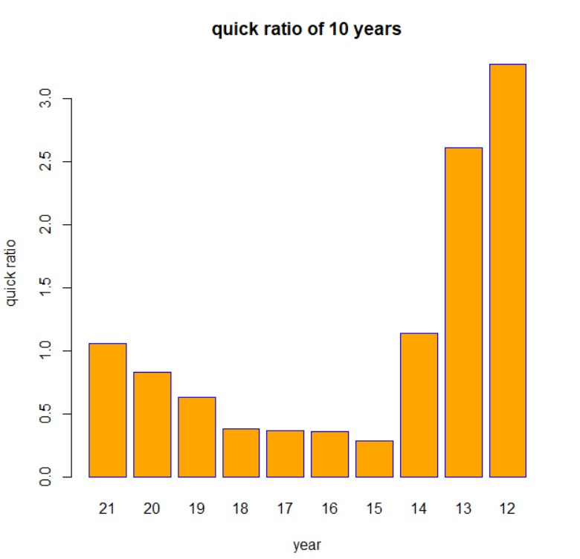

The Quick ratio measures a companys capacity to pay its current liabilities without any need in selling the inventory or by any additional financing. The ideal ratio is 1:1 that is the years with equal or above 1 are good. In the years 2020-2021 , 2013-2014, 2012-2013, 2011-2012 the company has sufficient liquid assets to satisfy its short term obligations. From 2015 to 2020 it had lessthan 1 which is not a good sign.

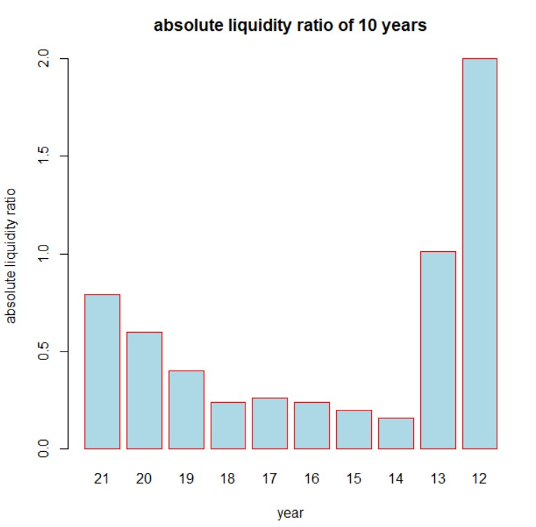

An absolute liquidity ratio test, same as a quick ratio, measures the ability of a company to use their short-term assets to cover their immediate liabilities.If it is greater than 1 is considered healthy and it is important for external stakeholders like creditors, lenders, investors and capitalists. In the years 2013, 2012 the company has faster inventor and cash conversion cycles compared to other years.

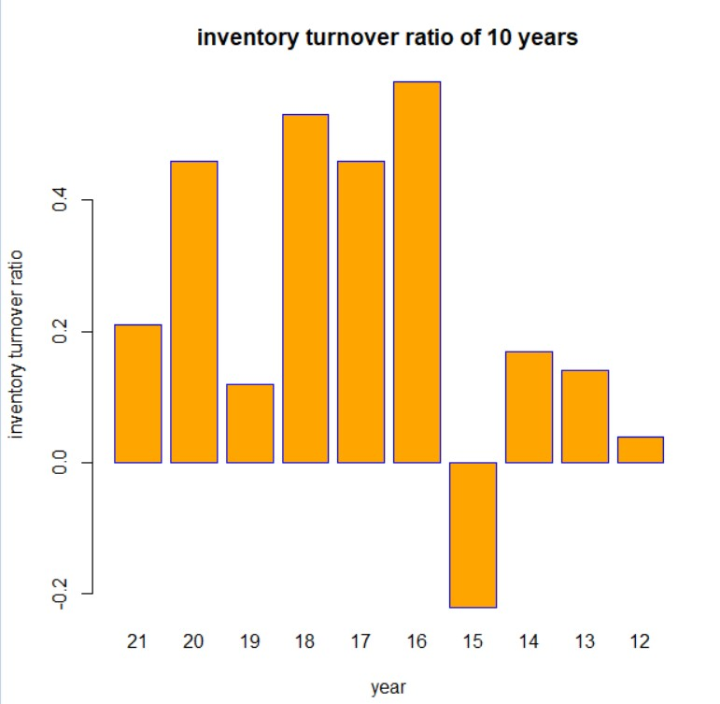

Inventory turnover is important because it highlights how efficient a company is at converting inventory into final sales and cash. The higher the ratio tends to point of strong sales and the lower to weak sales respectively. The company has strong sales in the year 2016, which implies the company sold its entire inventory 0.581 times in a given period and weak sales in the year 2015.

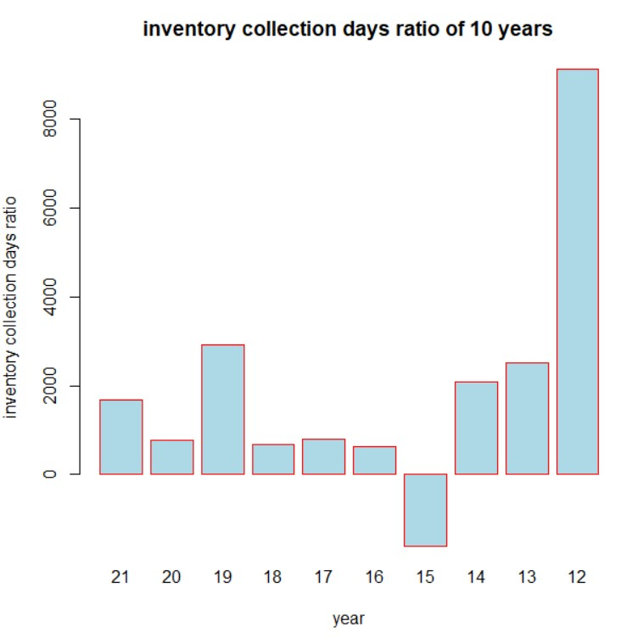

The number of days it takes to get cash or profit from inventory or the sales. The year 2012 is taking maximum days for conversion and to get profit it greatly effect the company’s financial position.

**PROFITABILITY RATIO:**

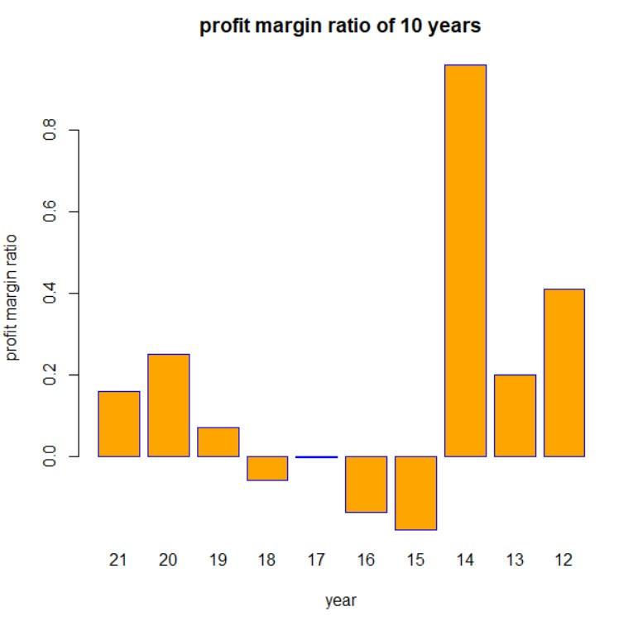

In the year 2014 the company saw the highest profit. Also, the company had been in the losses from 2015 to 218 where in the year 2017 it is neutral with no profit and loss.

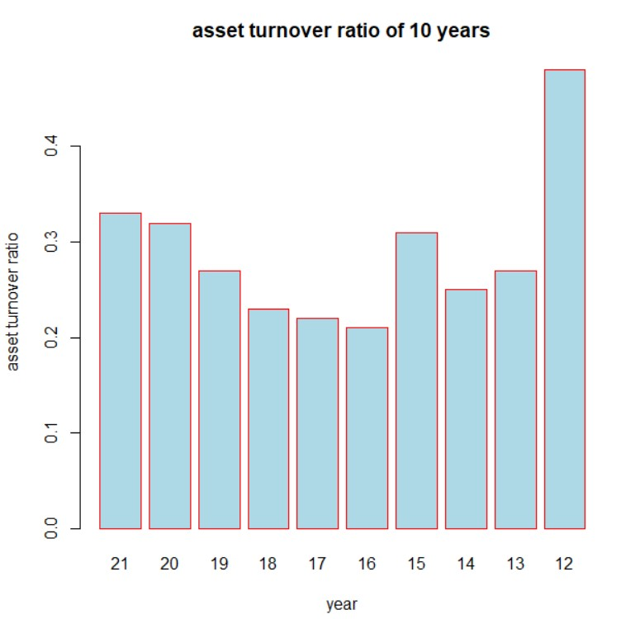

Asset turnover ratio measures the firm's efficiency in utilizing its assets indates how many times assets are turned over in a period to generate sales. In the year 2012 the company recorded the highest asset turnover that is 0.48 and the least utilization of assets is in 2016.

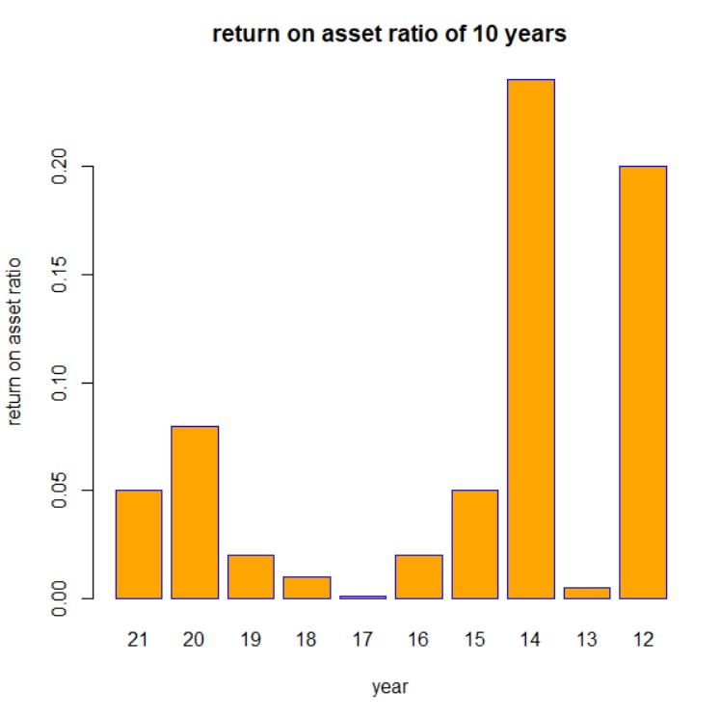

The higher the Return on asset the better is the companies performance. If it is around 5% it is better but from the above graph ratios are less than 1% hence it effects very badly.

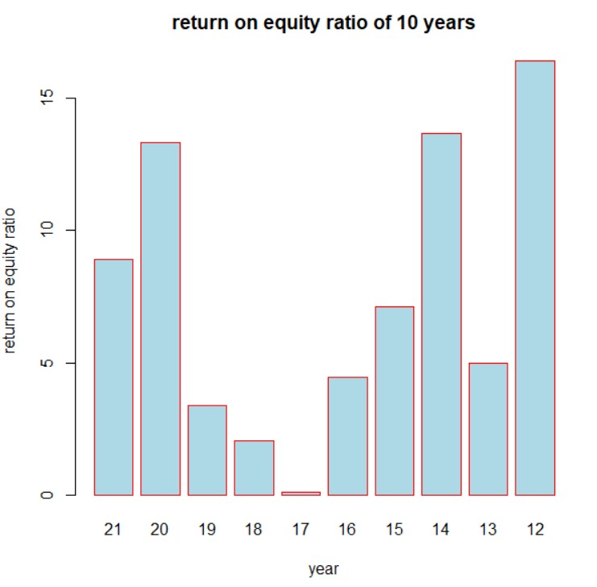

The ideal ratio is around 15% to 20%. The ratio measures finacial performance calculated by dividing net income and shareholders equity. In the year 2012 the company crossed 15% that is its return on equity are good when compared to other years.

**SOLVENCY RATIO:**

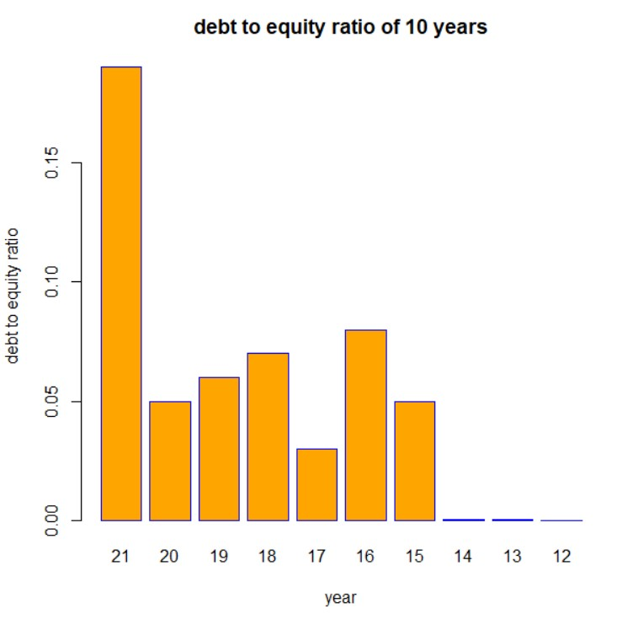

High debt to equity indicates a company is borrowing more capital from the market to fund its operations. It should not be above 2. Here in all the 10 years the company’s ratios are less than 2, which means it does not borrow much from the market, which is a good sign.

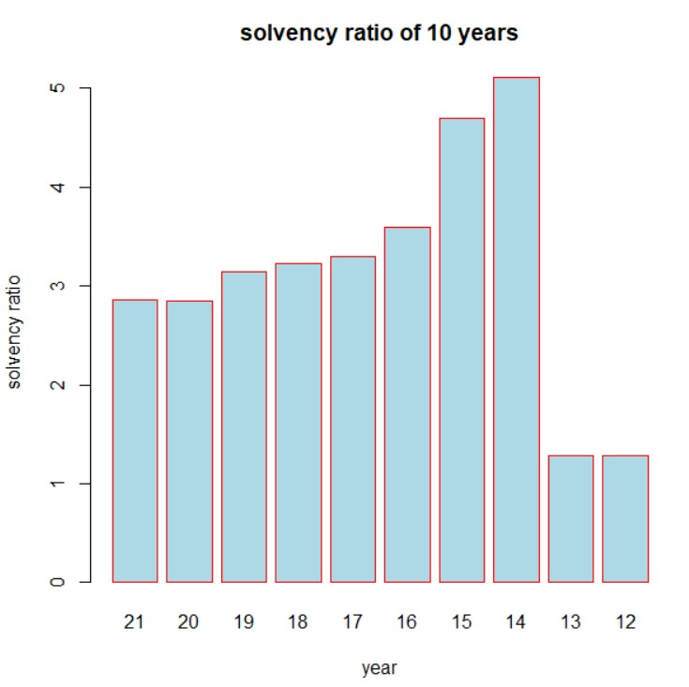

Solvency ratio indicates whether a company’s cash flow is sufficient to meet its long term liabilities. A high solvency ratio in the year 2015, 2014 shows that company can remain financially stable in long term.

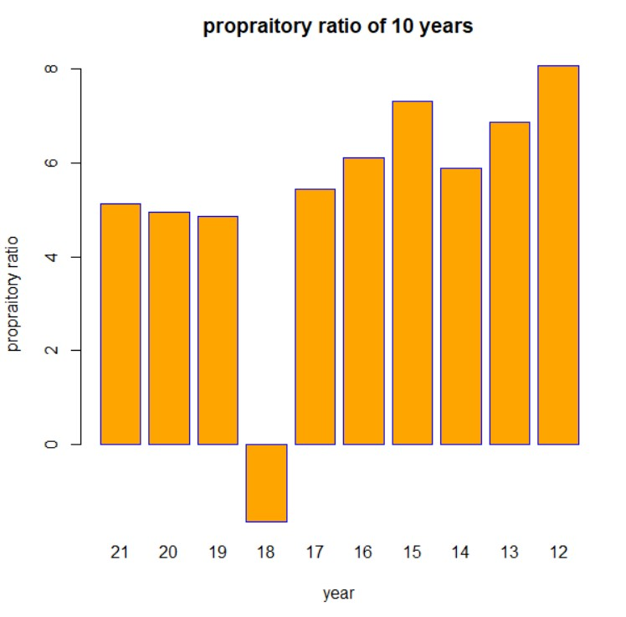

The higher the propraitory ratio the company is in strong in its business and it gives relief to the creditors. In the years 2021 and 2015 the company has reached highest which is a good sign but in the year 2018 the ratio is negative that it has a high amount of debt financing relative to its equity financing.

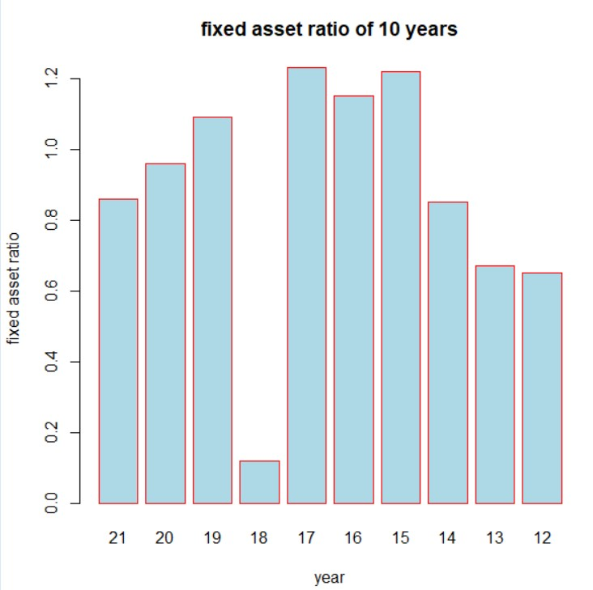

The ratio gives information about whether the company is investing wisely in its assets or not. The higher ratio in the years 2017,2015, 2015, and 19 respectively indicates the greater efficiency to generate sales from fixed asset. 2018 has the least efficiency in generating sales from assets.

**MARKET RELATED RATIOS:**

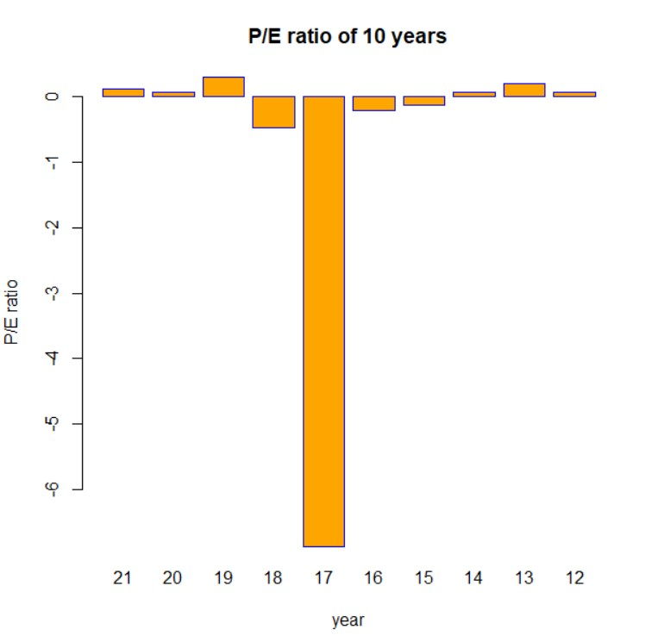

The negative ratio indicates that the company is losing the money that is company is reporting the loss. The graph shows that from 2015 to 2018 the company is in loss.

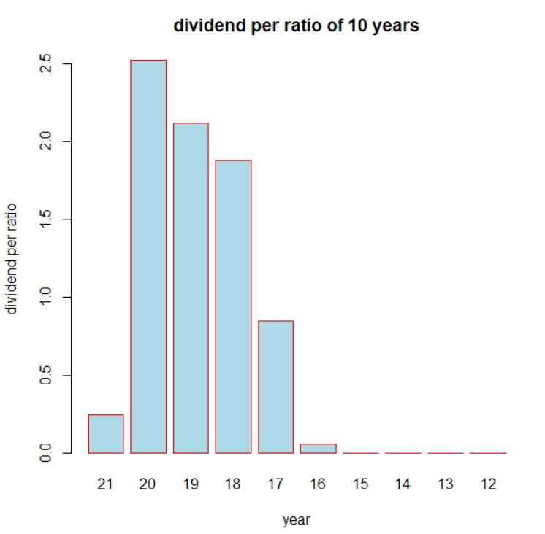

As the dividend per ratio is increasing from 2017 to 2020 the company is reinvesting less money back into the bussiness while paying out relatively more of its earning in form of dividends. In the years 2021, 2016 the ratio is least that means reinvesting more money back into business for its expansion.

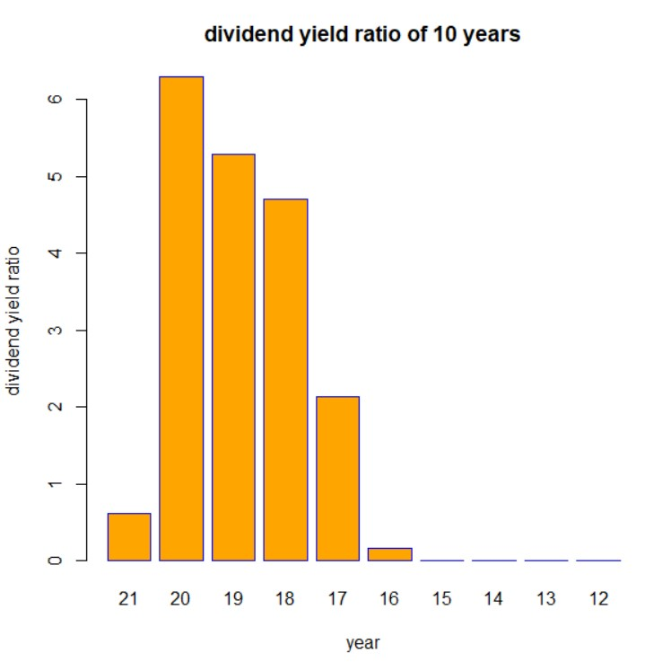

The % of a company’s share price that it pays out in dividends each year. The ratio is higher in the years 2020, 2019,2018 respectively which means the company signifies attractive investments. But from 2012 to 2015 they saw the least attractive investments which is not a good sign. This ratio also helps in comparison of different companies of the same size.

**INDUSTRIAL ANALYSIS:**

**LIQUIDITY RATIOS:**

CURRENT RATIO:

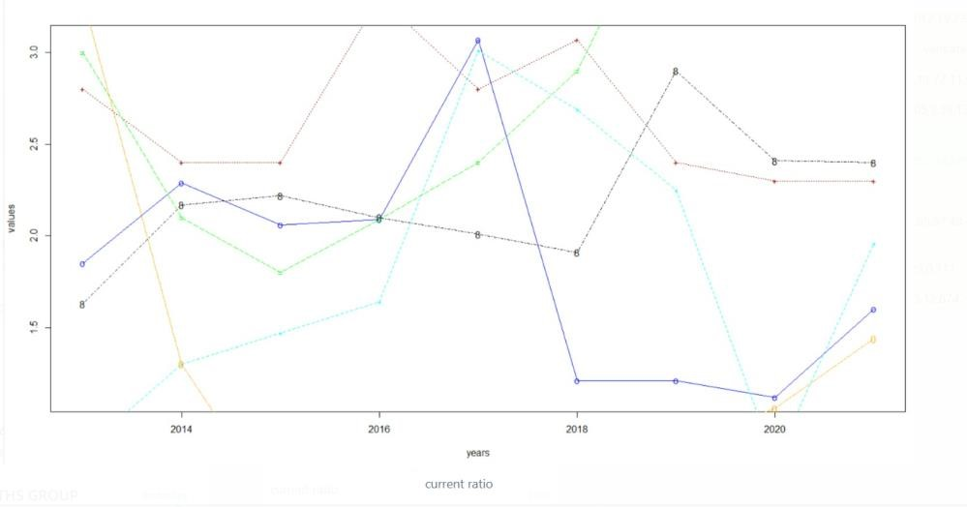

QUICK RATIO:

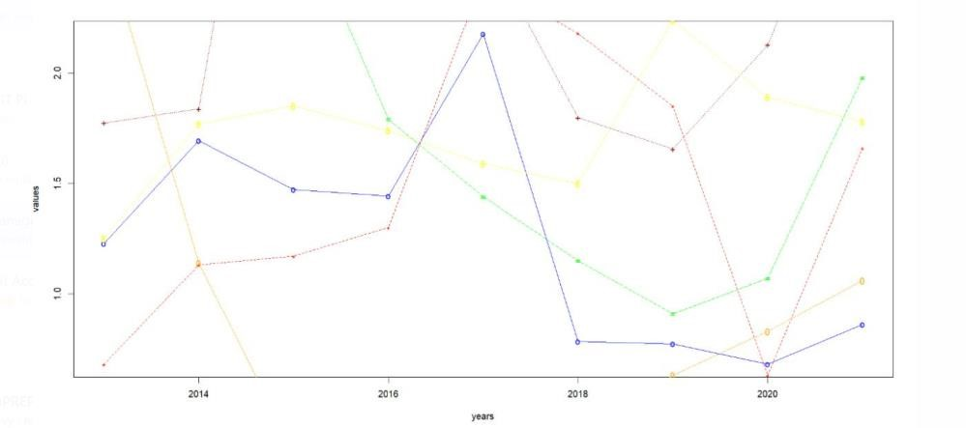

INVENTORY TURNOVER RATIO:

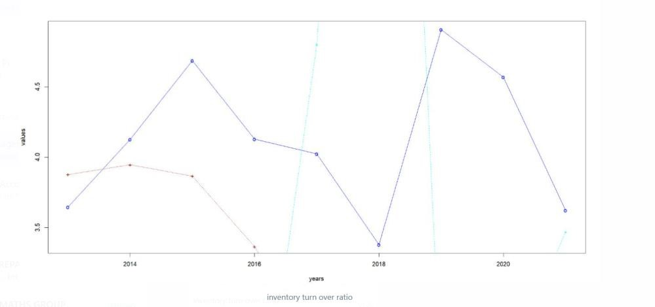

**PROFITABILITY RATIOS:**

PROFIT MARGIN:

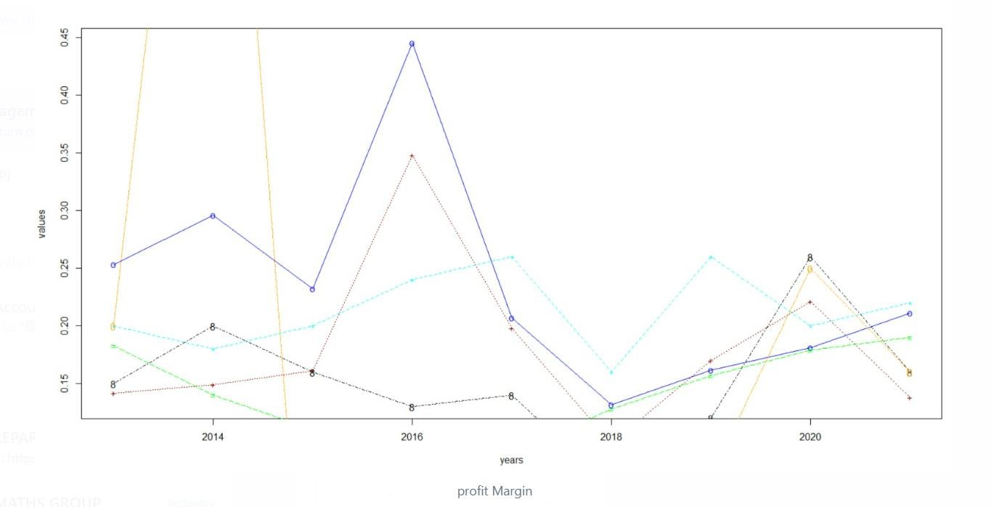

ASSET TURNOVER RATIO:

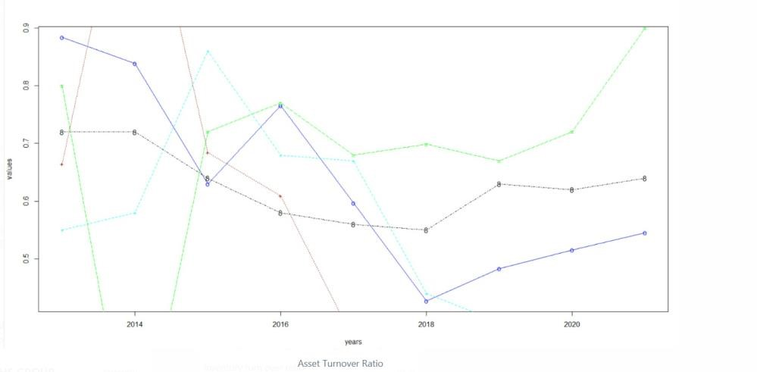

RETURN ON EQUITY:

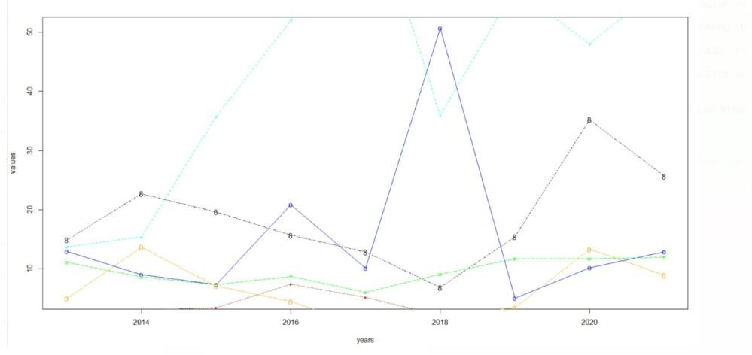

**SOLVENCY RATIOS:**

DEBT TO EQUITY:

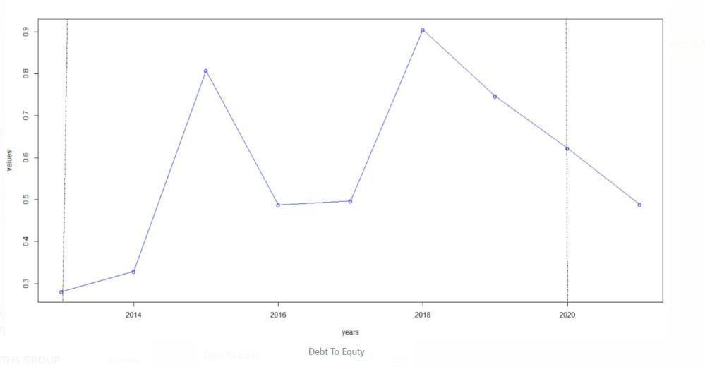

SOLVENCY:

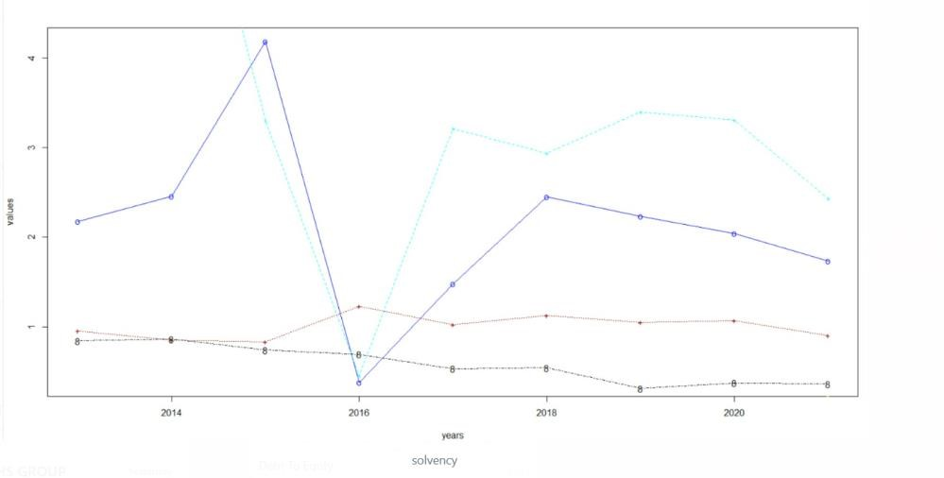

PROPRIOTARY RATIO:

